INFOSYS SOLUSI TERPADU



Documentation Cinema Reservation App

Leader :

Aris Kusnul Widitama

Asist :

Najib Djulfikar

Member :

Billy Marcellino

Titi Werdiningsih

**PERNYATAAN**

Dokumentasi Cinema Reservation App ini dibuat untuk memudahkan user dalam memahami alur sistem dari aplikasi. Dengan segala kekurangannya, kami berharap sinergi dari berbagai pihak untuk penyempurnaan dokumentasi. Tidak menutup kemungkinan versi dari dokumentasi ini akan berlanjut hingga mencapai kesempurnaan.

Demikian dokumentasi ini dibuat bersama dengan anggota kelompok yang tersebut diatas. Atas perhatian dan masukannya diucapkan terimakasih.

Dokumentasi Project Challenge 4 Kelompok 1

# **LEMBAR VERSI DOKUMEN**

**Catatan Release Dokumen**

|  |  |  |  |
| --- | --- | --- | --- |
| Tanggal Release | Versi | Oleh | Catatan Perubahan |
| 03 Juli 2022 | 1.0.1 | Kelompok B “Final Project” | Versi Pertama Bioskop API |
| 16 Juli 2022 | 1.0.2 | Kelompok B “Final Project” | Versi Kedua Bioskop API |

# **DAFTAR ISI**

**LEMBAR VERSI DOKUMEN** **4**

**DAFTAR ISI** **5**

**FLOWCHART DIAGRAM** **7**

**ENTITY RELATIONSHIP DIAGRAM DATABASE BIOSKOP** **8**

**SPESIFIKASI ENDPOINT FILM** **13**

Get All Films 13

Get Film by Name 17

Update Film 21

Create New Film 27

Delete Film by ID 32

**SPESIFIKASI ENDPOINT USER** **36**

Get All User 36

Get User By Name 39

Update User by Id 44

Create New User 48

Delete User by ID 53

**SPESIFIKASI ENDPOINT SEAT** **58**

Get All Seat 58

Get Seat by Studio Name 61

Update Seat By Id 66

Create New Seat 71

Delete Seat By Id 76

**SPESIFIKASI ENDPOINT SCHEDULE** **80**

Get All Schedule 80

Get Schedule by Price 85

Update Schedule by Id 91

Create New Schedule 98

Delete Schedule by Id 103

**SPESIFIKASI ENDPOINT RESERVATIONS** **107**

Get All Reservations 107

Get Reservations by Username 110

Update Reservations by ID 113

Create New Reservations 117

Delete Reservations by ID 121

# 

# **FLOWCHART DIAGRAM**

# **ENTITY RELATIONSHIP DIAGRAM DATABASE BIOSKOP**

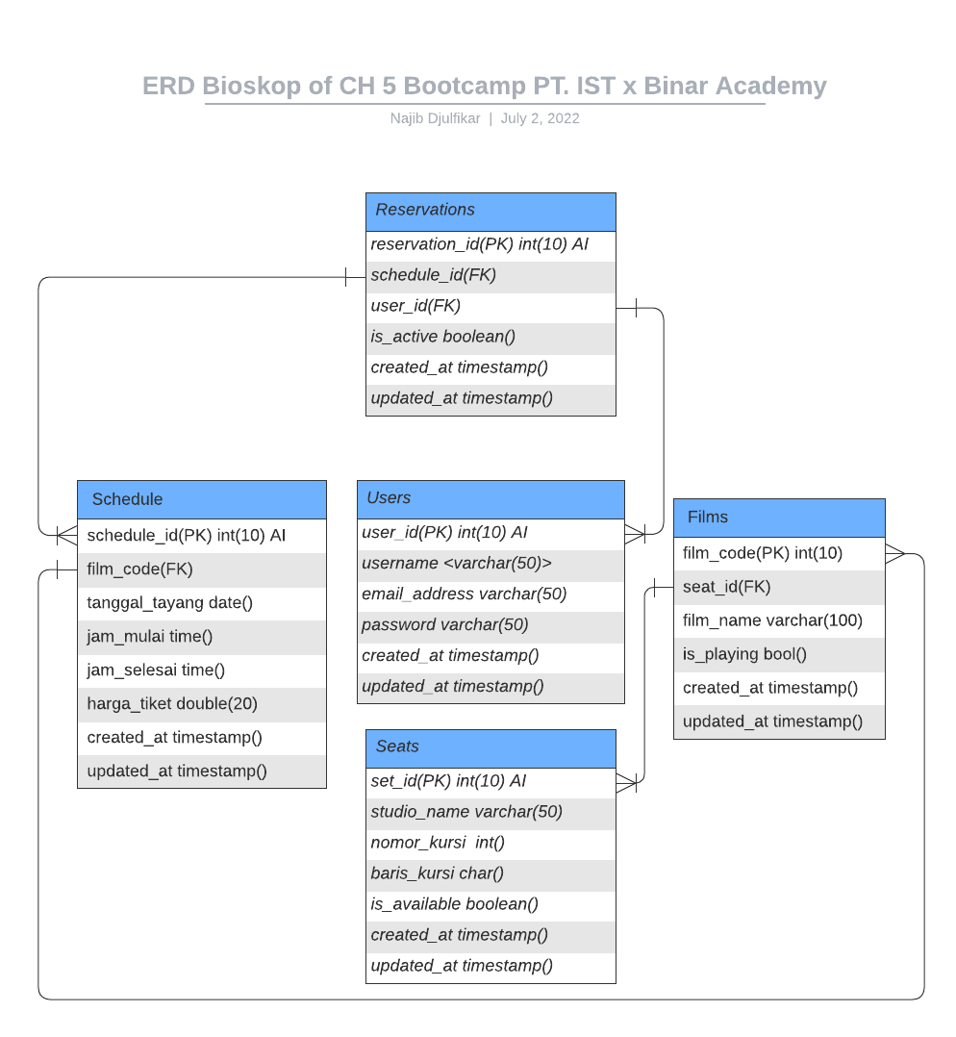

*Figure . Entity Relationship Diagram DB Bioskop*

**Explanation of Table**

* **Table Users**

|  |  |  |  |  |  |
| --- | --- | --- | --- | --- | --- |
| **Column Name** | **Data Type** | **Length** | **Not Null** | **Auto Increment** | **Key** |
| *user_id* | int | 10 | v | v | Primary Key |
| *username* | varchar | 50 | v | - | - |
| *email_address* | varchar | 50 | v | - | - |
| *password* | varchar | 50 | v | - | - |
| *created_at* | timestamp | - | v | - | - |
| *updated_at* | timestamp | - | - | - | - |

* **Table Seats**

|  |  |  |  |  |  |
| --- | --- | --- | --- | --- | --- |
| **Column Name** | **Data Type** | **Length** | **Not Null** | **Auto Increment** | **Key** |
| *seat_id* | int | 10 | v | v | Primary Key |
| *studio_name* | varchar | 50 | v | - | - |
| *nomor_kursi* | int | 10 | v | - | - |
| *baris_kursi* | char | 1 | - | - | - |
| *is_available* | boolean | 1 | - | - | - |
| *created_at* | timestamp | - | v | - | - |
| *updated_at* | timestamp | - | - | - | - |

* **Table Films**

|  |  |  |  |  |  |
| --- | --- | --- | --- | --- | --- |
| **Column Name** | **Data Type** | **Length** | **Not Null** | **Auto Increment** | **Key** |
| *film_code* | int | 10 | v | - | Primary Key |
| *seat_id* | int | 50 | v | - | Foreign Key |
| *film_name* | varchar | 100 | v | - | - |
| *is_playing* | boolean | 1 | v | - | - |
| *created_at* | timestamp | - | v | - | - |
| *updated_at* | timestamp | - | - | - | - |
| *film_code* | int | 10 | v | - | Primary Key |

* **Table Schedule**

|  |  |  |  |  |  |
| --- | --- | --- | --- | --- | --- |
| **Column Name** | **Data Type** | **Length** | **Not Null** | **Auto Increment** | **Key** |
| *schedule_id* | int | 10 | v | v | Primary Key |
| *film_code* | int | 50 | v | - | Foreign Key |
| *tanggal_tayang* | date | - | v | - | - |
| *jam_mulai* | time | - | v | - | - |
| *jam_selesai* | time | - | v | - | - |
| *harga_tiket* | double | - | v | - | - |
| *created_at* | timestamp | - | v | - | - |
| *updated_at* | timestamp | - | - | - | - |

* **Table Reservation**

|  |  |  |  |  |  |
| --- | --- | --- | --- | --- | --- |
| **Column Name** | **Data Type** | **Length** | **Not Null** | **Auto Increment** | **Key** |
| *reservation_id* | int | 10 | v | - | Primary Key |
| *user_id* | int | 10 | v | - | Foreign Key |
| *schedule_id* | int | 10 | v | - | Foreign Key |
| *is_active* | boolean | - | v | - | - |
| *created_at* | timestamp | - | v | - | - |
| *updated_at* | timestamp | - | - | - | - |

# 

# **SPESIFIKASI ENDPOINT FILM**

## **Get All Films**

**Endpoint Description**

Service berikut ini digunakan untuk memasukkan film baru ke dalam database bioskop.

**Request URL**

|  |
| --- |
| https://bioskop-lucu.herokuapp.com/crud/films/1 |

**General Information**

|  |  |
| --- | --- |
| HTTP Method | GET |
| Path | /films |
| Tipe Format | JSON |
| Authentication | - |

**Header Structure**

|  |  |
| --- | --- |
| **Key** | **Value** |
| Content-Type | Application/JSON |
| Transfer-Encoding | chunked |
| Date | Sat, 25 Jun 2022 12:38:15 GMT |
| Keep-Alive | timeout=60 |
| Connection | keep-alive |

**Request Structure**

* Structure is Not Available if fetching all data
* Use Path Variable “get by id” to fetch one/more data

**Response Structure**

**JSON**

|  |
| --- |
| **Response Structure** |
| {  "data": [  {  "filmCode": 702112,  "seatId": {  "seatId": 21,  "studioName": "Studio B",  "barisKursi": "B",  "isAvailable": true,  "nomorKursi": 20,  "createdAt": "2022-10-04T02:31:16",  "updatedAt": "2022-10-04T17:24:56"  },  "filmName": "A Quiete Place 2",  "isPlaying": true,  "createdAt": "2022-09-23T10:45:30",  "updatedAt": "2022-08-03T15:47:26"  }  ],  "message": "Successfully retrieve all Films!",  "status": "OK"  } |

|  |  |  |  |  |
| --- | --- | --- | --- | --- |
| **Field** | **Data Type** | **Length** | **Description** | **Example** |
| filmCode | Integer | 5 | Kode untuk Film | 12345 |
| seatId | Integer | 5 | Kode untuk setiap kursi | 1 |
| studioName | String | 50 | Nama Studio dari setiap seatId | Studio A |
| barisKursi | Char | 5 | Baris untuk setiap nomor kursi | A |
| isAvailable | Boolean | 1 | Status kursi kosong/ isi | true |
| nomorKursi | Integer | 5 | Nomor kursi di setiap studio | 1 |
| createdAt | TimeStamp | - | Waktu seatId di Record | 2022-09-17T05:43:49 |
| updatedAt | TimeStamp | - | Waktu seatId di Updated | 2022-10-13T12:52:50 |
| filmName | String | 100 | Nama Film | dunia lain |
| isPlaying | Boolean | 1 | Status Film Sedang Dimainkan/ Tidak | true |
| createdAt | TimeStamp | - | Waktu Film Pertama Kali Diinput | 2022-02-18T17:46:55 |
| updatedAt | TimeStamp | - | Waktu Film Terakhir Kali Diperbarui | 2022-06-11T01:57:03 |

## 

**Get All Film with Tyhmleaf - Bootstrap :**

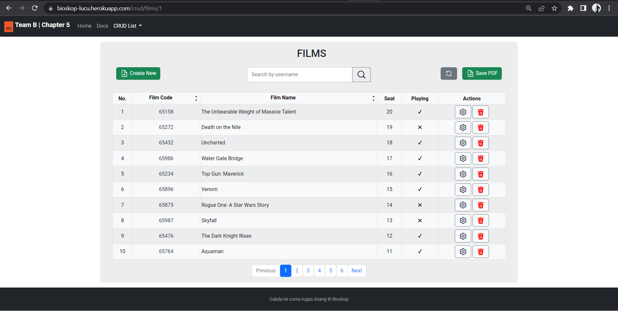

## **Get Film by Name**

**Endpoint Description**

Service berikut ini digunakan untuk mengambil satu data film berdasarkan id film yang ada di dalam database bioskop.

**Request URL**

|  |
| --- |
| https://bioskop-lucu.herokuapp.com/crud/films/1 |

**General Information**

|  |  |
| --- | --- |
| HTTP Method | GET |
| Path | /films/{id} |
| Tipe Format | JSON |
| Authentication | - |

**Header Structure**

|  |  |
| --- | --- |
| Key | Value |
| Content-Type | Application/JSON |
| Transfer-Encoding | chunked |
| Date | Fri, 25 Jun 2022 11.45:04 GMT |
| Keep-Alive | timeout=20 |
| Connection | keep-alive |

**Request Structure**

* **Path Variable**

**Response Structure**

**JSON**

|  |
| --- |
| **Response Structure** |
| {  "data": {  "filmCode": 73148,  "seatId": {  "seatId": 4,  "studioName": "Studio A",  "barisKursi": "A",  "isAvailable": true,  "nomorKursi": 12,  "createdAt": "2022-04-27T08:46:21",  "updatedAt": "2022-06-30T12:52:04"  },  "filmName": "Morbius",  "isPlaying": true,  "createdAt": "2022-03-01T09:55:42",  "updatedAt": "2022-08-27T20:29:11"  },  "message": "Successfully get film by id!",  "status": "OK"  } |

|  |  |  |  |  |  |
| --- | --- | --- | --- | --- | --- |
| **Field** | **Data Type** | **Mandatory** | **Length** | **Description** | **Example** |
| filmcode | Integer | Not Null | 5 | Nomor Film | 73148 |
| seatId | Integer | - | 100 | Kode film | 4 |
| studioName | String | - | 50 | Nama Studio | Studio A |
| barisKursi | Char | - | 1 | Nama alfa baris kursi | A |
| isAvailable | Boolean | - | 1 | Status available kursi | true |
| nomorKursi | Integer | - | 5 | Nomor Kursi | 12 |
| createdAt | Timestamp | - | - | Waktu pertama kali data terekam | 2022-04-15T17:02:24 |
| updatedAt | Timestamp | - | - | Waktu terakhir di perbarui | 2022-01-31T22:53:04 |
| filmName | String | - | 100 | Nama Film | Morbius |
| isPlaying | Boolean | - | 1 | Film yang sedang tayang atau tidak | True |
| createdAt | Timestamp | - | - | Waktu pertama kali data terekam | 2022-03-01T09:55:42 |
| updatedAt | Timestamp | - | - | Waktu terakhir di perbarui | 2022-08-27T20:29:11 |

**Get Film by Name with Tyhmleaf - Bootstrap :**

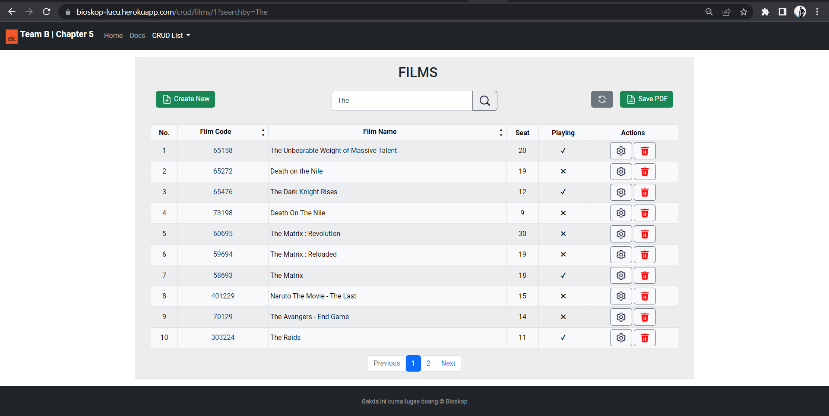

## **Update Film**

**Endpoint Description**

Service update film ini digunakan untuk update data film berdasarkan id dan film name yang ada di dalam database bioskop berdasarkan id films.

**Request URL**

|  |
| --- |
| https://bioskop-lucu.herokuapp.com/crud/films/1 |

**General Information**

|  |  |
| --- | --- |
| HTTP Method | UPDATE |
| Path | /films/id |
| Tipe Format | JSON |
| Authentication | - |

**Header Structure**

|  |  |
| --- | --- |
| Key | Value |
| Content-Type | Application/JSON |
| Transfer-Encoding | chunked |
| Date | Fri, 24 Jun 2022 12:42:04 GMT |
| Keep-Alive | timeout=20 |
| Connection | keep-alive |

**Request Structure**

**JSON**

|  |
| --- |
| **Request Structure** |
| {  "filmCode": 1893745,  "seatId": {  "seatId": 30,  },  "filmName": "Marhaba",  "isPlaying": true  } |

|  |  |  |  |  |  |
| --- | --- | --- | --- | --- | --- |
| **Field** | **Data Type** | **Mandatory** | **Length** | **Description** | **Example** |
| filmcode | Int | Not Null | 5 | Nomor Film | 189375 |
| seatId | Int | - | 5 | Kode film | 30 |
| filmName | varchart | - | 100 | Nama Film | Marhaba |
| isPlaying | tinyint | - | 1 | Film yang sedang tayang atau tidak | True |

**Response Structure**

**JSON**

|  |
| --- |
| **Response Structure** |
| {  "data": {  "filmCode": 1893745,  "seatId": {  "seatId": 30,  "studioName": "Studio D",  "barisKursi": "D",  "isAvailable": true,  "nomorKursi": 1,  "createdAt": "2022-04-15T17:02:24",  "updatedAt": "2022-01-31T22:53:04"  },  "filmName": "Marhaba",  "isPlaying": true,  "createdAt": null,  "updatedAt": "2022-06-28T22:41:33.2035181"  },  "message": "Films Updated!",  "status": "OK"  } |

|  |  |  |  |  |  |
| --- | --- | --- | --- | --- | --- |
| **Field** | **Data Type** | **Mandatory** | **Length** | **Description** | **Example** |
| filmcode | Integer | Not Null | 5 | Nomor Film | 1893745 |
| seatId | Integer | - | 100 | Kode film | 30 |
| studioName | String | - | 50 | Nama Studio | Studio D |
| barisKursi | Char | - | 1 | Nama alfa baris kursi | D |
| isAvailable | Boolean | - | 1 | Status available kursi | true |
| nomorKursi | Integer | - | 5 | Nomor Kursi | 1 |
| createdAt | Timestamp | - | - | Waktu pertama kali data terekam | 2022-04-15T17:02:24 |
| updatedAt | Timestamp | - | - | Waktu terakhir di perbarui | 2022-01-31T22:53:04 |
| filmName | String | - | 100 | Nama Film | Marhaba |
| isPlaying | Boolean | - | 1 | Film yang sedang tayang atau tidak | True |
| createdAt | Timestamp | - | - | Waktu pertama kali data terekam | 2022-03-01T09:55:42 |
| updatedAt | Timestamp | - | - | Waktu terakhir di perbarui | 2022-08-27T20:29:11 |

**Update Film with Tyhmleaf - Bootstrap :**

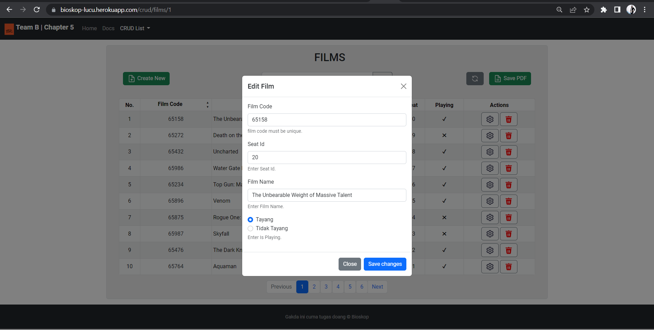

## **Create New Film**

**Endpoint Description**

Service berikut ini digunakan untuk mengambil semua film yang ada di dalam database bioskop.

**Request URL**

|  |
| --- |
| https://bioskop-lucu.herokuapp.com/crud/films/1 |

**General Information**

|  |  |
| --- | --- |
| HTTP Method | POST |
| Path | /films |
| Tipe Format | JSON |
| Authentication | - |

**Header Structure**

|  |  |
| --- | --- |
| **Key** | **Value** |
| Content-Type | Application/JSON |
| Transfer-Encoding | chunked |
| Date | Sat, 25 Jun 2022 12:45:20GMT |
| Keep-Alive | timeout=60 |
| Connection | keep-alive |

**Request Structure**

|  |
| --- |
| **Request Structure** |
| {  "filmCode": 555,  "seatId": {  "seatId": 50,  "studioName": "studio B",  "barisKursi": "H",  "isAvailable": true,  "nomorKursi": 1,  "createdAt": "2022-06-29T12:32:39.846Z",  "updatedAt": "2022-06-29T12:32:39.846Z"  },  "filmName": "string",  "isPlaying": true  } |

|  |  |  |  |  |
| --- | --- | --- | --- | --- |
| **Field** | **Data Type** | **Length** | **Description** | **Example** |
| filmCode | Integer | 5 | Kode untuk Film | 70129 |
| seatId | Integer | 5 | Kode untuk setiap kursi | 30 |
| filmName | String | 100 | Nama Film | The Avengers - End Game |
| isPlaying | Boolean | 1 | Status Film Sedang Dimainkan/ Tidak | true |

**Response Structure**

|  |
| --- |
| **Response Structure** |
| {  "data": {  "filmCode": 555,  "seatId": {  "seatId": 50,  "studioName": "Studio E",  "barisKursi": "E",  "isAvailable": true,  "nomorKursi": 21,  "createdAt": "2022-08-11T20:42:26",  "updatedAt": "2022-04-19T04:21:48"  },  "filmName": "string",  "isPlaying": true  },  "message": "Films Successfully Recorded",  "status": "OK"  } |

|  |  |  |  |  |
| --- | --- | --- | --- | --- |
| **Field** | **Data Type** | **Length** | **Description** | **Example** |
| filmCode | Integer | 5 | Kode untuk Film | 70129 |
| seatId | Integer | 5 | Kode untuk setiap kursi | 30 |
| studioName | String | 50 | Nama Studio dari setiap seatId | Studio D |
| barisKursi | Char | 5 | Baris untuk setiap nomor kursi | D |
| isAvailable | Boolean | 1 | Status kursi kosong/ isi | true |
| nomorKursi | Integer | 5 | Nomor kursi di setiap studio | 1 |
| createdAt | TimeStamp | - | Waktu seatId di Record | 2022-09-17T05:43:49 |
| updatedAt | TimeStamp | - | Waktu seatId di Updated | 2022-10-13T12:52:50 |
| filmName | String | 100 | Nama Film | The Avengers - End Game |
| isPlaying | Boolean | 1 | Status Film Sedang Dimainkan/ Tidak | true |

**Create Film with Tyhmleaf - Bootstrap :**

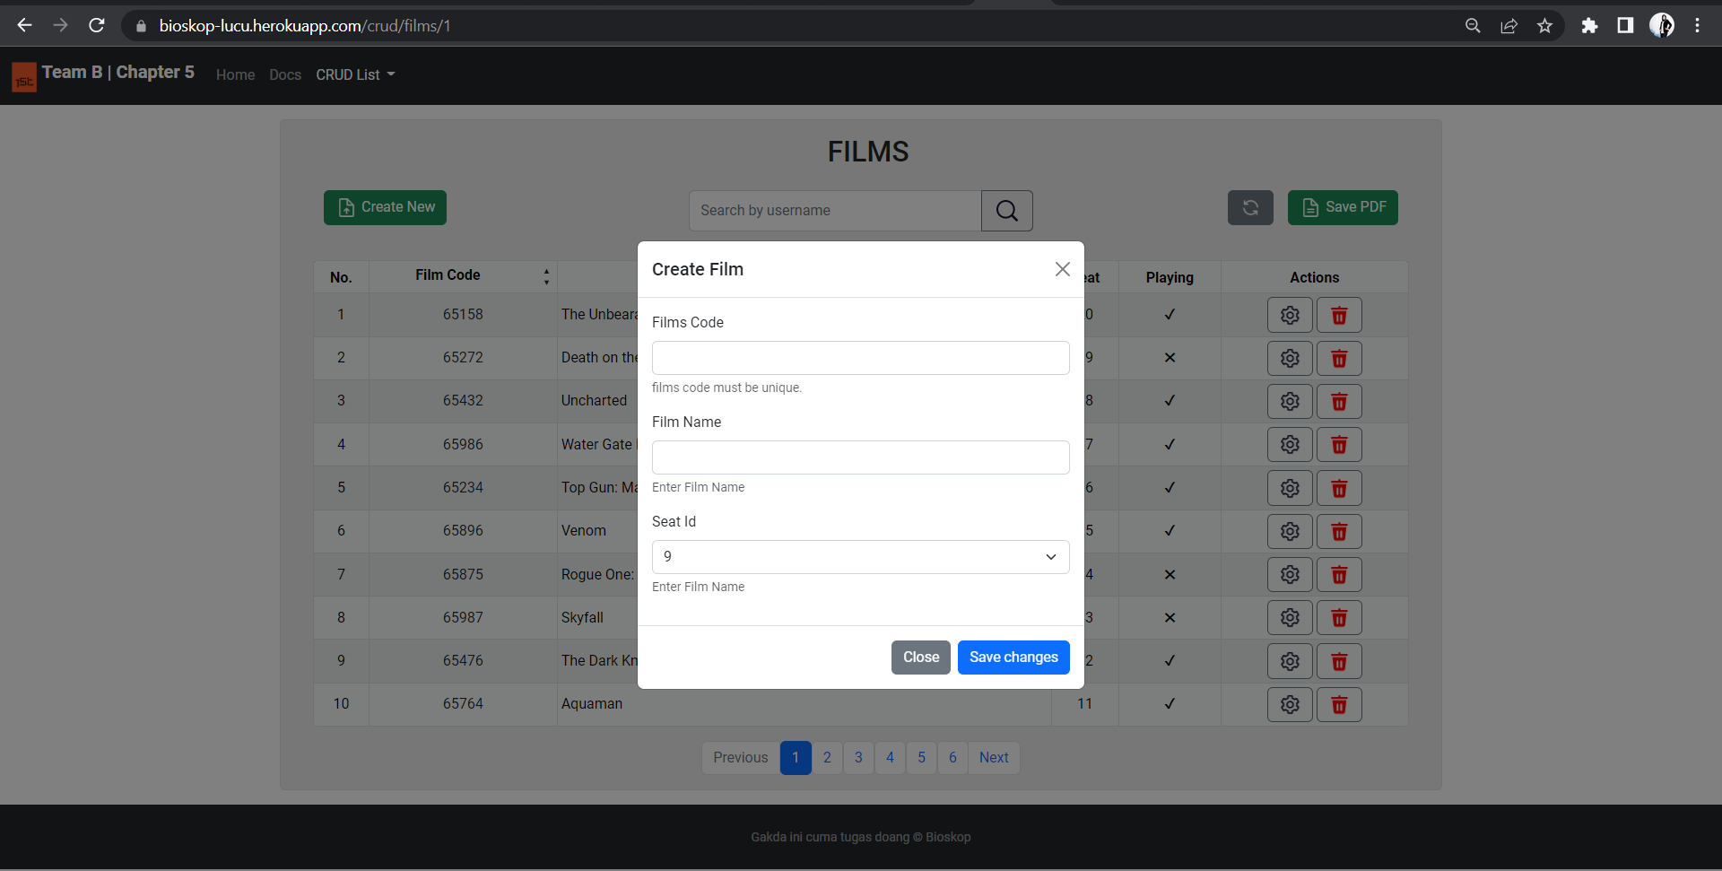

## **Delete Film by ID**

**Endpoint Description**

Service berikut ini digunakan untuk menghapus secara *hard-delete data* film yang telah dibuat sebelumnya berdasarkan Id Path Variable pada Endpoint.

**Request URL**

|  |
| --- |
| https://bioskop-lucu.herokuapp.com/crud/films/1 |

**General Information**

|  |  |
| --- | --- |
| HTTP Method | DELETE |
| Path | /films/id |
| Tipe Format | JSON |
| Authentication | - |

**Header Structure**

|  |  |
| --- | --- |
| **Key** | **Value** |
| Content-Type | Application/JSON |
| Transfer-Encoding | chunked |
| Date | Sat, 25 Jun 2022 13:10:15 GMT |
| Keep-Alive | timeout=60 |
| Connection | keep-alive |

**Request Structure**

* Path Variable for delete one data

**Response Structure**

* HTTP STATUS OK (200)

|  |
| --- |
| **Response Structure** |
| {  "data": {  "filmCode": 58693,  "seatId": null,  "filmName": null,  "isPlaying": null,  "createdAt": null,  "updatedAt": null  },  "message": "Films Deleted!",  "status": "OK"  } |

**Delete Film with Tyhmleaf - Bootstrap :**

## 

# **SPESIFIKASI ENDPOINT USER**

## **Get All User**

**Endpoint Description**

Service berikut ini digunakan untuk mengambil keseluruhan data *user* yang ada.

**Request URL**

|  |
| --- |
| https://bioskop-lucu.herokuapp.com/crud/users/1 |

**General Information**

|  |  |
| --- | --- |
| HTTP Method | GET |
| Path | /users |
| Tipe Format | JSON |
| Authentication | - |

**Header Structure**

|  |  |
| --- | --- |
| Key | Value |
| Content-Type | Application/JSON |
| Transfer-Encoding | chunked |
| Date | Tue,28 Jun 2022 17:08:40 GMT |
| Keep-Alive | timeout=60 |
| Connection | keep-alive |

**Request Structure**

N/A

**Response Structure**

**JSON**

|  |
| --- |
| **Response Structure** |
| {  "data": [  {  "userId": 1,  "username": "Reidara",  "emailAddress": "rthirsk0@phoca.cz",  "password": "baANbC",  "createdAt": "2022-06-21T05:06:01",  "updatedAt": "2022-11-22T10:09:53"  },  {  "userId": 2,  "username": "Adriannaa",  "emailAddress": "anaismith1@quantcast.com",  "password": "ZQAW3d",  "createdAt": "2022-02-02T05:22:34",  "updatedAt": "2022-01-07T02:44:32"  },  ],  "message": "Successfully retrieved data!",  "status": "OK"  } |

|  |  |  |  |  |  |
| --- | --- | --- | --- | --- | --- |
| **Field** | **Data Type** | **Mandatory** | **Length** | **Description** | **Example** |
| userId | Integer | Not Null | - | Id user | 1 |
| username | String | Not Null | 50 | *Username* untuk *authentication* | username123 |
| emailAddress | String | Not Null | 50 | Alamat email pengguna | example@mail.com |
| password | String | Not Null | 50 | Password pengguna | asd32csf72k |
| createdAt | Timestamp | Not Null | - | Waktu pertama kali data dibuat | 2022-06-21T05:06:01 |
| updatedAt | Timestamp | Not Null | - | Waktu terakhir kali data kursi diperbaharui | 2022-11-22T10:09:53 |

**Get All User with Tyhmleaf - Bootstrap :**

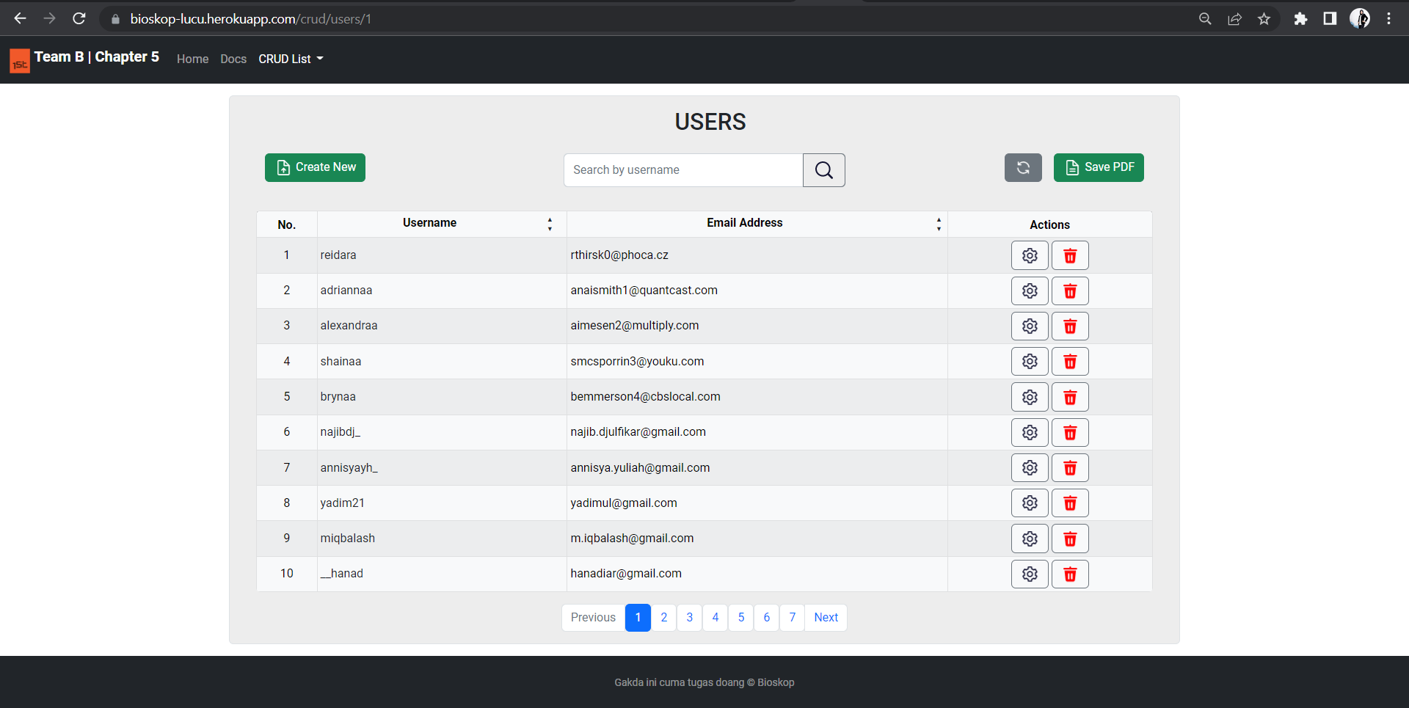

## **Get User By Name**

**Endpoint Description**

Service berikut ini digunakan untuk mengambil data satu *user* berdasarkan id *user*.

**Request URL**

|  |
| --- |
| https://bioskop-lucu.herokuapp.com/crud/users/1 |

**General Information**

|  |  |
| --- | --- |
| HTTP Method | GET |
| Path | /user/{id} |
| Tipe Format | JSON |
| Authentication | - |

**Header Structure**

|  |  |
| --- | --- |
| Key | Value |
| Content-Type | Application/JSON |
| Transfer-Encoding | chunked |
| Date | Tue,28 Jun 2022 17:10:40 GMT |
| Keep-Alive | timeout=60 |
| Connection | keep-alive |

**Request Structure**

* **Path Variable**

**Response Structure**

**JSON**

|  |
| --- |
| **Response Structure** |
| {  "data": {  "userId": 1,  "username": "Reidara",  "emailAddress": "rthirsk0@phoca.cz",  "password": "baANbC",  "createdAt": "2022-06-21T05:06:01",  "updatedAt": "2022-11-22T10:09:53"  },  "message": "Successfully retrieved data!",  "status": "OK"  } |

|  |  |  |  |  |  |
| --- | --- | --- | --- | --- | --- |
| **Field** | **Data Type** | **Mandatory** | **Length** | **Description** | **Example** |
| userId | Integer | Not Null | - | Id user | 1 |
| username | String | Not Null | 50 | *Username* untuk *authentication* | username123 |
| emailAddress | String | Not Null | 50 | Alamat email pengguna | example@mail.com |
| password | String | Not Null | 50 | Password pengguna | asd32csf72k |
| createdAt | Timestamp | Not Null | - | Waktu pertama kali data dibuat | 2022-06-21T05:06:01 |
| updatedAt | Timestamp | Not Null | - | Waktu terakhir kali data kursi diperbaharui | 2022-11-22T10:09:53 |

**Get User by Name with Tyhmleaf - Bootstrap :**

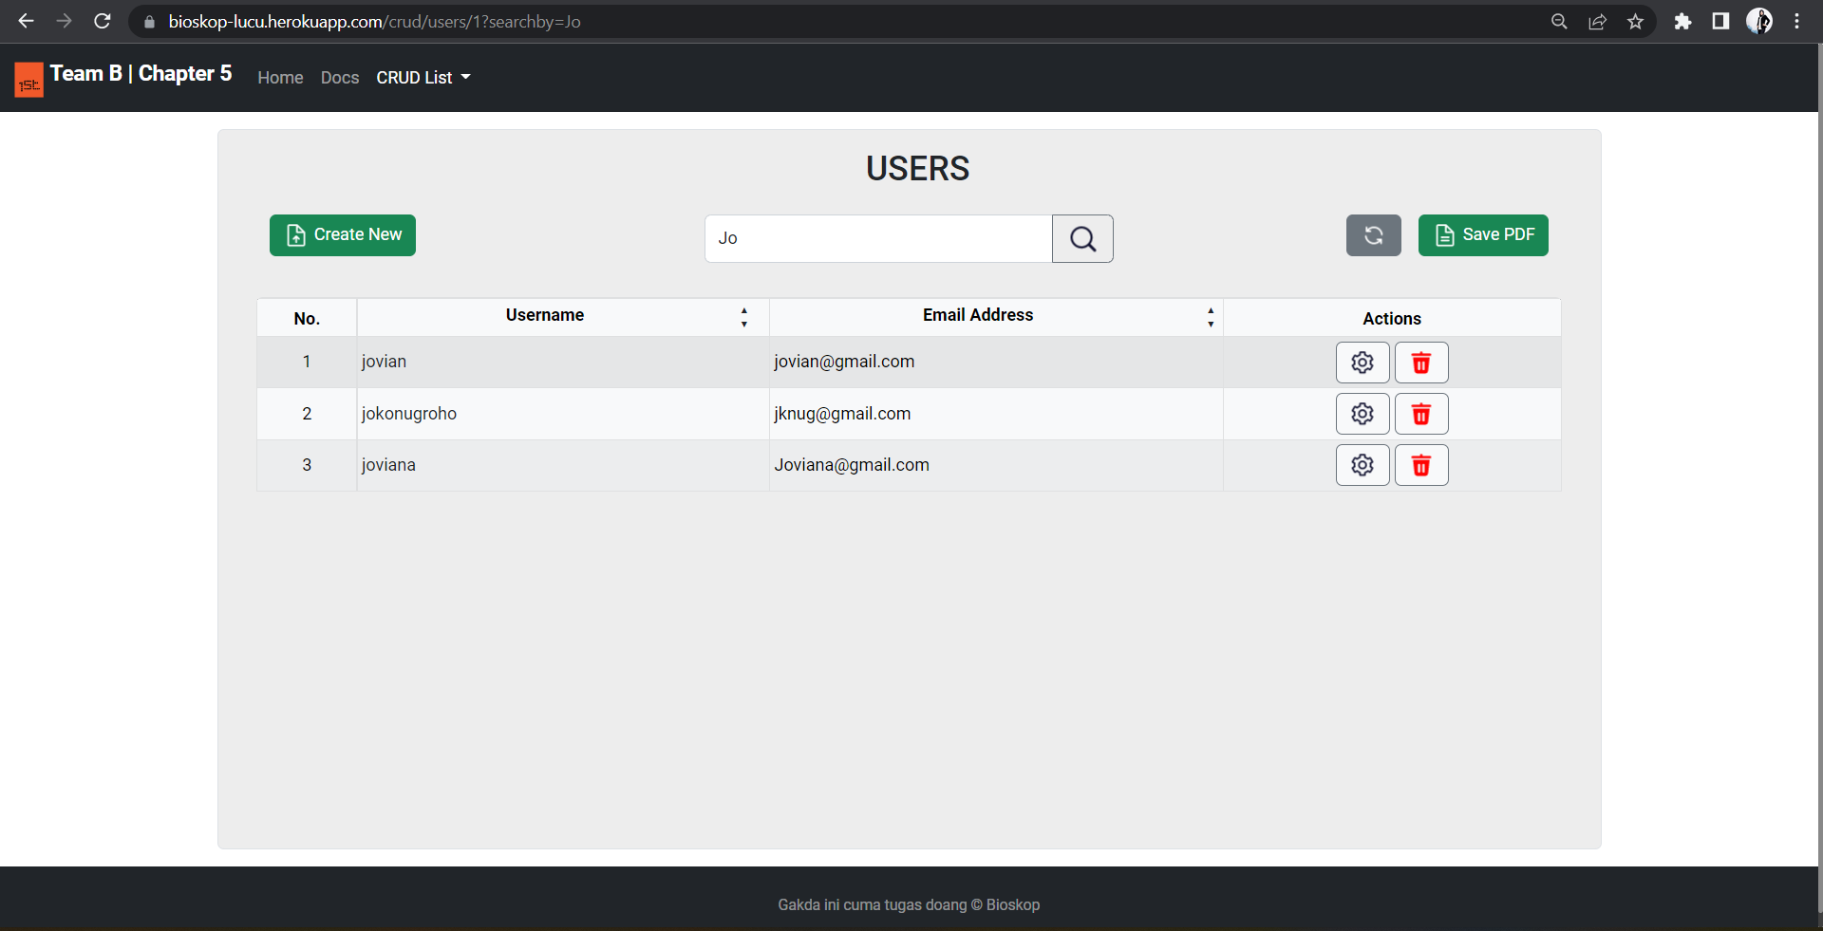

## 

## **Update User by Id**

**Endpoint Description**

Service berikut ini digunakan untuk mengubah data *user*.

**Request URL**

|  |
| --- |
| https://bioskop-lucu.herokuapp.com/crud/users/1 |

**General Information**

|  |  |
| --- | --- |
| HTTP Method | PUT |
| Path | /user |
| Tipe Format | JSON |
| Authentication | - |

**Header Structure**

|  |  |
| --- | --- |
| Key | Value |
| Content-Type | Application/JSON |
| Transfer-Encoding | chunked |
| Date | Tue,28 Jun 2022 17:18:40 GMT |
| Keep-Alive | timeout=60 |
| Connection | keep-alive |

**Request Structure**

**JSON**

|  |
| --- |
| **Request Structure** |
| {  "userId": 68,  "username": "JUNGKOOK",  "emailAddress": "kookie@gmail.com",  "password": "K00K1E",  "createdAt": "2022-06-28T17:17:46.863Z",  "updatedAt": "2022-06-28T17:17:46.863Z"  } |

|  |  |  |  |  |  |
| --- | --- | --- | --- | --- | --- |
| **Field** | **Data Type** | **Mandatory** | **Length** | **Description** | **Example** |
| userId | Integer | Not Null | - | Id user | 1 |
| username | String | Not Null | 50 | *Username* untuk *authentication* | username123 |
| emailAddress | String | Not Null | 50 | Alamat email pengguna | example@mail.com |
| password | String | Not Null | 50 | Password pengguna | asd32csf72k |
| createdAt | Timestamp | Not Null | - | Waktu pertama kali data dibuat | 2022-06-21T05:06:01 |
| updatedAt | Timestamp | Not Null | - | Waktu terakhir kali data kursi diperbaharui | 2022-11-22T10:09:53 |

**Response Structure**

**JSON**

|  |
| --- |
| **Response Structure** |
| {  "data": {  "userId": 68,  "username": "JUNGKOOK",  "emailAddress": "kookie@gmail.com",  "password": "K00K1E",  "createdAt": "2022-06-28T17:17:46.863",  "updatedAt": "2022-06-29T00:18:40.5377225"  },  "message": "Data successfully updated",  "status": "OK"  } |

|  |  |  |  |  |  |
| --- | --- | --- | --- | --- | --- |
| **Field** | **Data Type** | **Mandatory** | **Length** | **Description** | **Example** |
| userId | Integer | Not Null | - | Id user | 1 |
| username | String | Not Null | 50 | *Username* untuk *authentication* | username123 |
| emailAddress | String | Not Null | 50 | Alamat email pengguna | example@mail.com |
| password | String | Not Null | 50 | Password pengguna | asd32csf72k |
| createdAt | Timestamp | Not Null | - | Waktu pertama kali data dibuat | 2022-06-21T05:06:01 |
| updatedAt | Timestamp | Not Null | - | Waktu terakhir kali data kursi diperbaharui | 2022-11-22T10:09:53 |

**Update User with Tyhmleaf - Bootstrap :**

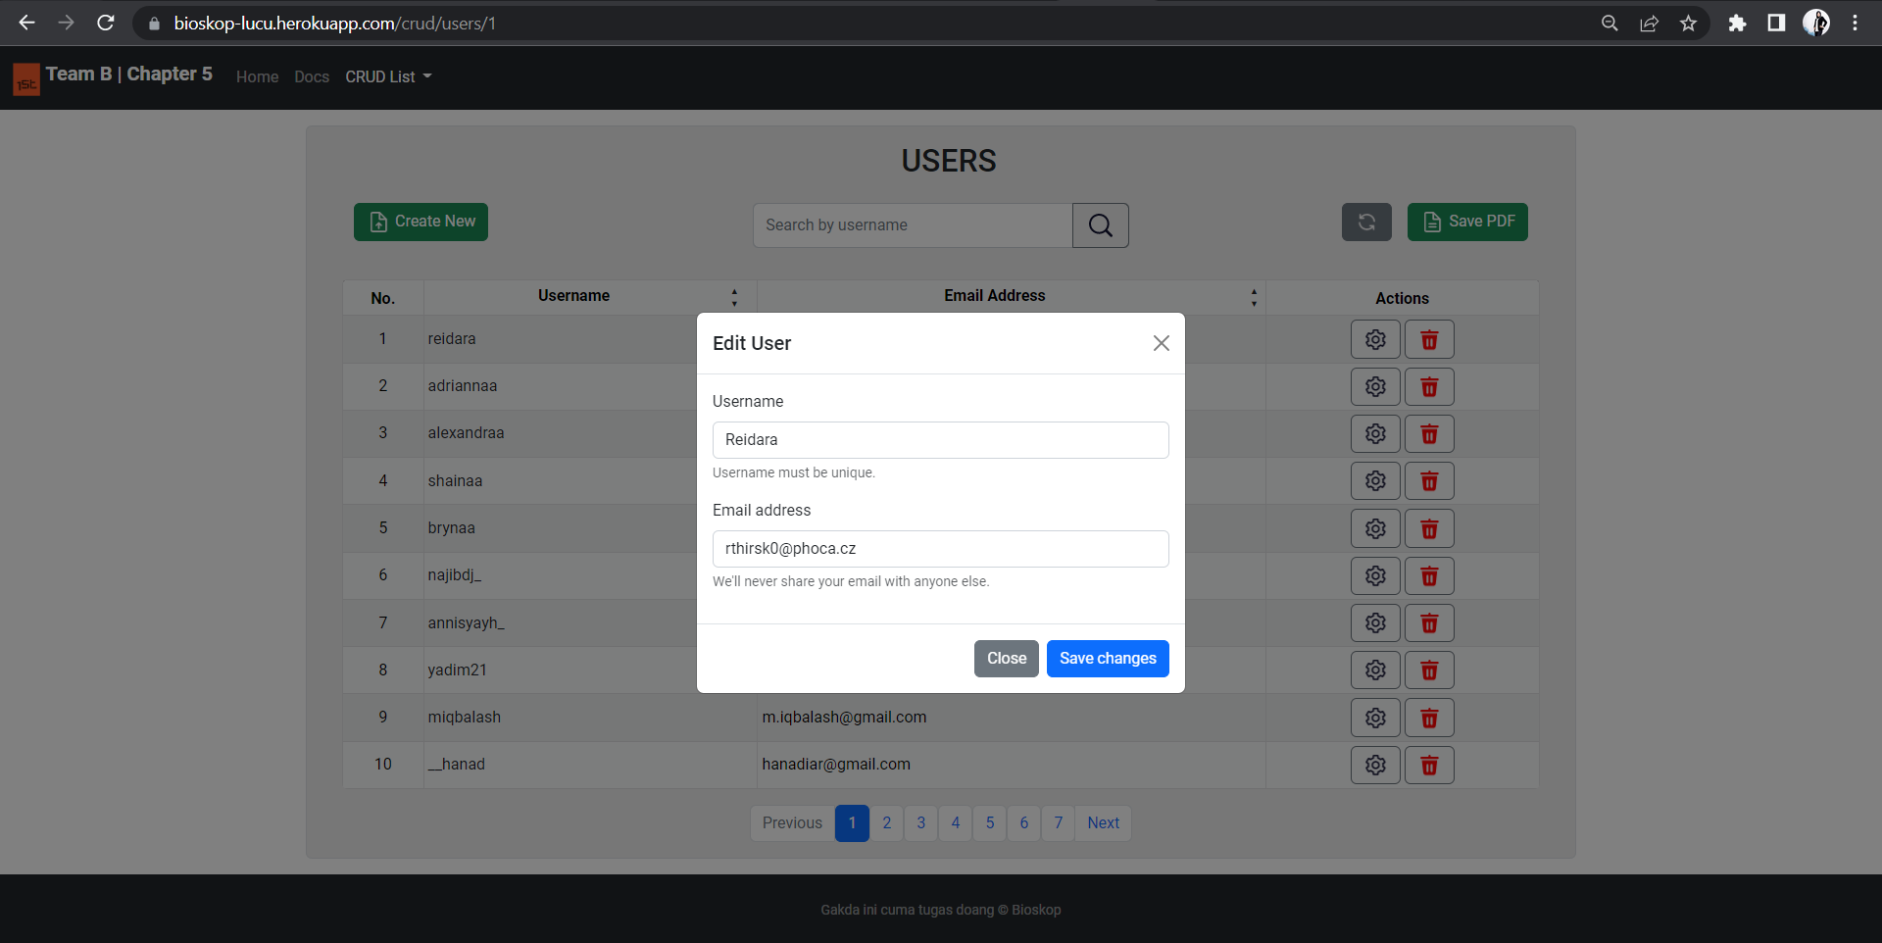

## **Create New User**

**Endpoint Description**

Service berikut ini digunakan untuk mengubah data *user*.

**Request URL**

|  |
| --- |
| https://bioskop-lucu.herokuapp.com/crud/users/1 |

**General Information**

|  |  |
| --- | --- |
| HTTP Method | POST |
| Path | /user |
| Tipe Format | JSON |
| Authentication | - |

**Header Structure**

|  |  |
| --- | --- |
| Key | Value |
| Content-Type | Application/JSON |
| Transfer-Encoding | chunked |
| Date | Tue,28 Jun 2022 17:12:40 GMT |
| Keep-Alive | timeout=60 |
| Connection | keep-alive |

**Request Structure**

* **JSON**

|  |
| --- |
| **Request Structure** |
| {  "userId": 67,  "username": "Sun Bin",  "emailAddress": "sunbin@gmail.com",  "password": "SUN81N",  "createdAt": "2022-06-28T16:12:42.657Z",  "updatedAt": "2022-06-28T16:12:42.657Z"  } |

|  |  |  |  |  |  |
| --- | --- | --- | --- | --- | --- |
| **Field** | **Data Type** | **Mandatory** | **Length** | **Description** | **Example** |
| userId |  |  |  |  |  |
| username | String | Not Null | 50 | *Username* untuk *authentication* | username123 |
| emailAddress | String | Not Null | 50 | Alamat email pengguna | example@mail.com |
| password | String | Not Null | 50 | Password pengguna | asd32csf72k |
| createdAt | Timestamp | Not Null | - | Waktu pertama kali data dibuat | 2022-06-28T16:12:42.657Z |
| updatedAt | Timestamp | Not Null | - | Waktu terakhir kali data kursi diperbaharui | 2022-06-28T16:12:42.657Z |

**Response Structure**

**JSON**

|  |
| --- |
| **Response Structure** |
| {  "data": {  "userId": 67,  "username": "Sun Bin",  "emailAddress": "[sunbin@gmail.com](mailto:sunbin@gmail.com)",  "password": "SUN81N",  "createdAt": "2022-06-28T23:14:45.3660691",  "updatedAt": "2022-06-28T23:14:45.3660691"  },  "message": "Data successfully inserted!",  "status": "OK"  } |

|  |  |  |  |  |  |
| --- | --- | --- | --- | --- | --- |
| **Field** | **Data Type** | **Mandatory** | **Length** | **Description** | **Example** |
| userId | Integer | Not Null | - | Id user | 1 |
| username | String | Not Null | 50 | *Username* untuk *authentication* | username123 |
| emailAddress | String | Not Null | 50 | Alamat email pengguna | example@mail.com |
| password | String | Not Null | 50 | Password pengguna | asd32csf72k |
| createdAt | Timestamp | Not Null | - | Waktu pertama kali data dibuat | 2022-06-21T05:06:01 |
| updatedAt | Timestamp | Not Null | - | Waktu terakhir kali data kursi diperbaharui | 2022-11-22T10:09:53 |

**Create User with Tyhmleaf - Bootstrap :**

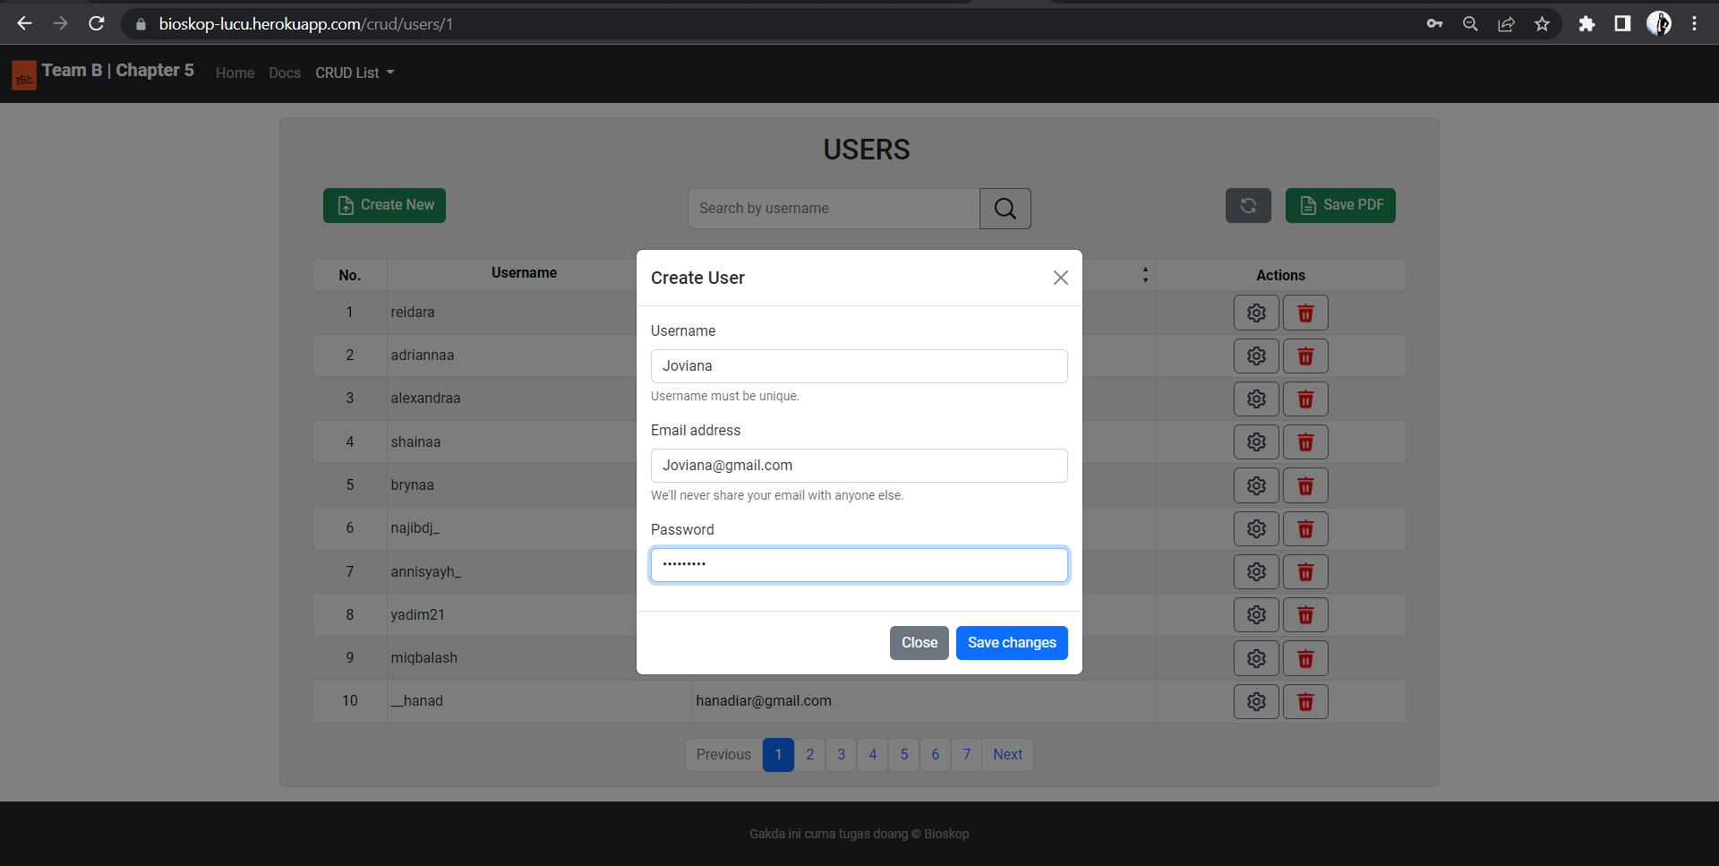

## **Delete User by ID**

**Endpoint Description**

Service berikut ini digunakan untuk mengambil data satu *user* berdasarkan id *user*.

**Request URL**

|  |
| --- |
| https://bioskop-lucu.herokuapp.com/crud/users/1 |

**General Information**

|  |  |
| --- | --- |
| HTTP Method | DELETE |
| Path | /user/{id} |
| Tipe Format | JSON |
| Authentication | - |

**Header Structure**

|  |  |
| --- | --- |
| Key | Value |
| Content-Type | Application/JSON |
| Transfer-Encoding | chunked |
| Date | Tue,28 Jun 2022 18:18:40 GMT |
| Keep-Alive | timeout=60 |
| Connection | keep-alive |

**Request Structure**

* **Path Variable**

**Response Structure**

**JSON**

|  |
| --- |
| **Response Structure** |
| {  "data": {  "userId": 69,  "username": "TOM CRUISE",  "emailAddress": "tomcr@gmail.com",  "password": "T0MCR",  "createdAt": "2022-06-29T00:07:20",  "updatedAt": "2022-06-29T00:07:20"  },  "message": "Successfully delete user!",  "status": "OK"  } |

|  |  |  |  |  |  |
| --- | --- | --- | --- | --- | --- |
| **Field** | **Data Type** | **Mandatory** | **Length** | **Description** | **Example** |
| userId | Integer | Not Null | - | Id user | 1 |
| username | String | Not Null | 50 | *Username* untuk *authentication* | username123 |
| emailAddress | String | Not Null | 50 | Alamat email pengguna | example@mail.com |
| password | String | Not Null | 50 | Password pengguna | asd32csf72k |
| createdAt | Timestamp | Not Null | - | Waktu pertama kali data dibuat | 2022-06-21T05:06:01 |
| updatedAt | Timestamp | Not Null | - | Waktu terakhir kali data kursi diperbaharui | 2022-11-22T10:09:53 |

**Delete User with Tyhmleaf - Bootstrap :**

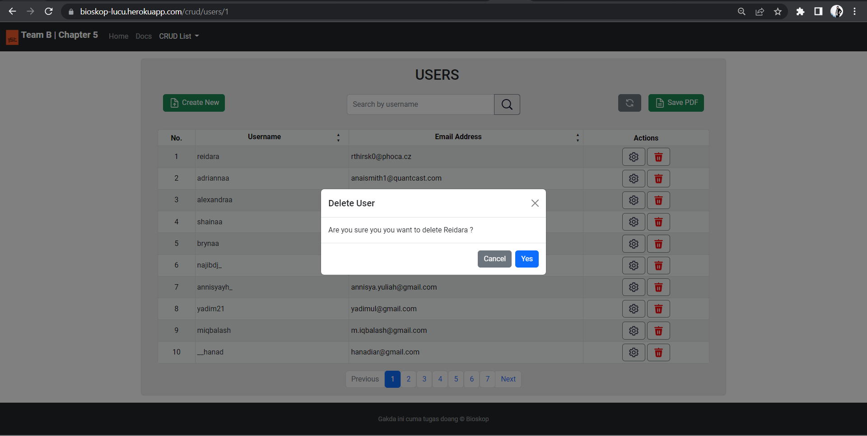

# 

# **SPESIFIKASI ENDPOINT SEAT**

## **Get All Seat**

**Endpoint Description**

Service berikut ini digunakan untuk mengambil keseluruhan data kursi bioskop yang ada di database.

**Request URL**

|  |
| --- |
| https://bioskop-lucu.herokuapp.com/crud/seats/1 |

**General Information**

|  |  |
| --- | --- |
| HTTP Method | GET |
| Path | /schedules (All Data)  /schedule/{id} (One Data) |
| Tipe Format | JSON |
| Authentication | - |

**Header Structure**

|  |  |
| --- | --- |
| **Key** | **Value** |
| Content Type | Application/JSON |
| Transfer-Encoding | Chunked |
| Date | Fri, 24 Jun 2022 12:47:04 GMT |
| Keep Alive | timeout=60 |
| Connection | keep alive |

**Request Structure**

N/A

**Response Structure**

**JSON**

|  |
| --- |
| **Response Structure** |
| {  "data": [  {  "seatId": 65,  "studioName": "Studio J",  "barisKursi": "J",  "isAvailable": true,  "nomorKursi": 17,  "createdAt": "2022-09-30T15:28:04",  "updatedAt": "2022-09-02T21:21:37"  }  ],  "message": "Successfully retrieved data!",  "status": "OK"  } |

|  |  |  |  |  |  |
| --- | --- | --- | --- | --- | --- |
| **Field** | **Data Type** | **Mandatory** | **Length** | **Description** | **Example** |
| seatId | Integer | - | - | Primary key dari seat | 3 |
| studioName | String | - | 50 | nama dari studio bioskop | Studio A |
| nomorKursi | Integer | - | - | nomor dari kursi bioskop | 5 |
| isAvailable | Boolean | - | 1 | status kursi yg tersedia | true |
| createdAt | String | - | 1 | waktu pertama kali data kursi diinput | 2022-06-13 23:58:01 |
| createdAt | String | - | 1 | waktu pertama kali data kursi diupdate | 2022-01-07 05:08:16 |

**Get All Seat with Tyhmleaf - Bootstrap :**

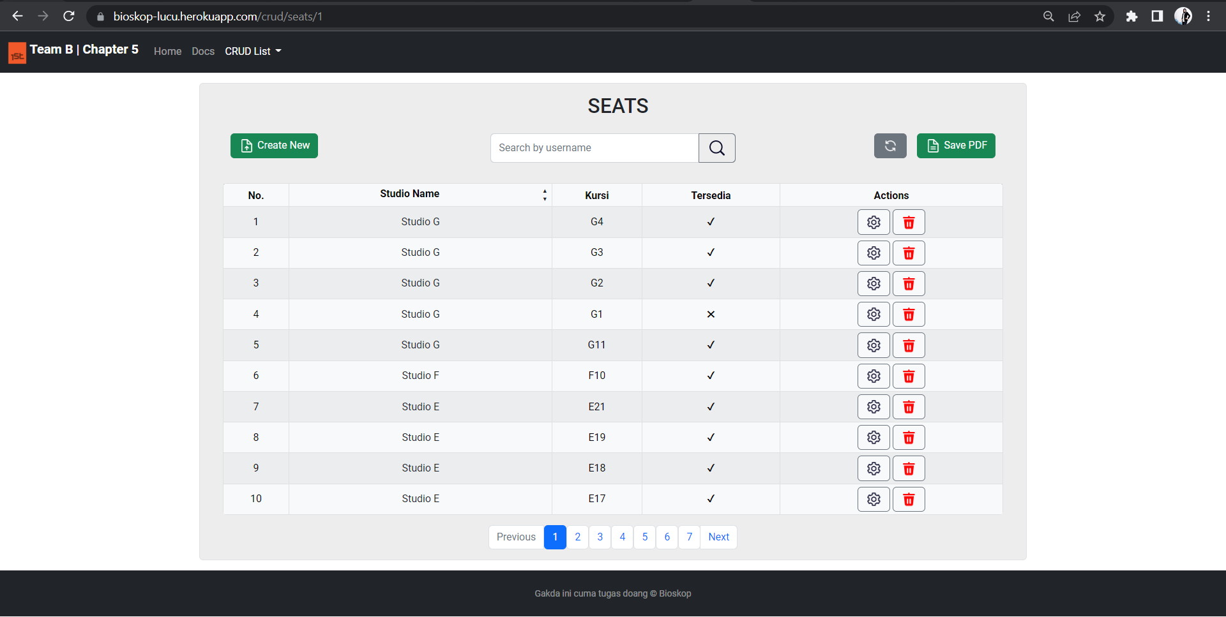

## **Get Seat by Studio Name**

**Endpoint Description**

Service berikut ini digunakan untuk merubahkan data kursi dan mengganti data bioskop yang telah ada di database.

**Request URL**

|  |
| --- |
| https://bioskop-lucu.herokuapp.com/crud/seats/1 |

**General Information**

|  |  |
| --- | --- |
| HTTP Method | GET |
| Path | /seats |
| Tipe Format | JSON |
| Authentication | - |

**Header Structure**

|  |  |
| --- | --- |
| **Key** | **Value** |
| Content Type | Application/JSON |
| Transfer-Encoding | Chunked |
| Date | Fri, 24 Jun 2022 12:47:04 GMT |
| Keep Alive | timeout=60 |
| Connection | keep alive |

**Request Structure**

**JSON**

|  |
| --- |
| **Request Structure** |
| {  "seatId": 7,  "studioName": "string",  "nomorKursi": 25,  "isAvailable": true,  "createdAt": "2022-06-26T14:19:40.366Z",  "updatedAt": "2022-06-26T14:19:40.366Z"  } |

|  |  |  |  |  |  |
| --- | --- | --- | --- | --- | --- |
| **Field** | **Data Type** | **Mandatory** | **Length** | **Description** | **Example** |
| seatId | Integer | - | - | Primary key dari seat | 3 |
| studioName | String | - | 50 | nama dari studio bioskop | Studio A |
| isAvailable | Boolean | - | 1 | status kursi yg tersedia | true |
| createdAt | String | - | 1 | waktu pertama kali data kursi diinput | 2022-06-13 23:58:01 |
| createdAt | String | - | 1 | waktu pertama kali data kursi diupdate | 2022-01-07 05:08:16 |

**Response Structure**

**JSON**

|  |
| --- |
| **Response Structure** |
| {  "data": {  "seatId": 1,  "studioName": "Studio A",  "barisKursi": "A",  "isAvailable": true,  "nomorKursi": 1,  "createdAt": "2022-06-13T23:58:01",  "updatedAt": "2022-01-07T05:08:16"  },  "message": "Successfully retrieved data!",  "status": "OK"  } |

|  |  |  |  |  |  |
| --- | --- | --- | --- | --- | --- |
| **Field** | **Data Type** | **Mandatory** | **Length** | **Description** | **Example** |
| seatId | Integer | - | - | Primary key dari seat | 3 |
| studioName | String | - | 50 | nama dari studio bioskop | Studio A |
| nomorKursi | Integer | - | - | nomor dari kursi bioskop | 5 |
| isAvailable | Boolean | - | 1 | status kursi yg tersedia | true |
| createdAt | String | - | 1 | waktu pertama kali data kursi diinput | 2022-06-13 23:58:01 |
| createdAt | String | - | 1 | waktu pertama kali data kursi diupdate | 2022-01-07 05:08:16 |

**Get Seat by Studio Name with Tyhmleaf - Bootstrap :**

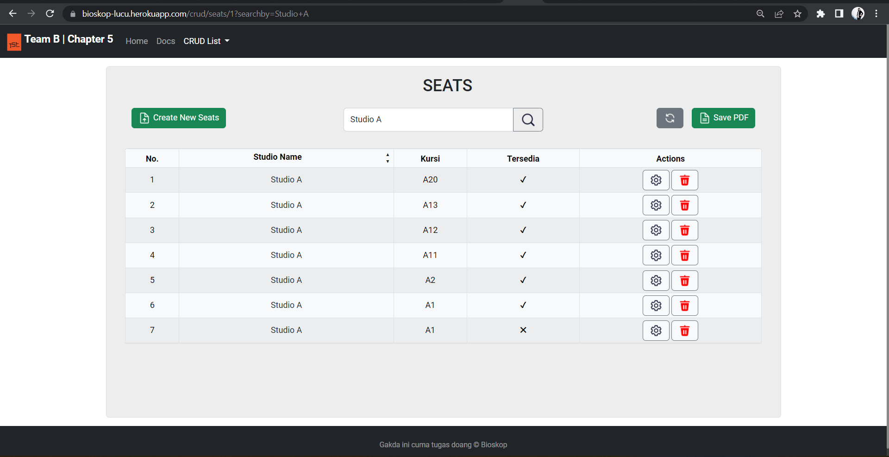

## **Update Seat By Id**

**Endpoint Description**

Service berikut ini digunakan untuk menambahkan data kursi pada bioskop menjadi tersedia didalam database.

**Request URL**

|  |
| --- |
| https://bioskop-lucu.herokuapp.com/crud/seats/1 |

**General Information**

|  |  |
| --- | --- |
| HTTP Method | GET |
| Path | /seats/available |
| Tipe Format | JSON |
| Authentication | - |

**Header Structure**

|  |  |
| --- | --- |
| Key | Value |
| Content Type | Application/JSON |
| Transfer-Encoding | Chunked |
| Date | Fri, 24 Jun 2022 12:47:04 GMT |
| Keep Alive | timeout=60 |
| Connection | keep alive |

**Request Structure**

**JSON**

|  |
| --- |
| **Request Structure** |
| {  "seatId": 3,  "studioName": "A",  "nomorKursi": 3,  "isAvailable": true,  "createdAt": "2022-06-26T14:34:37.270Z",  "updatedAt": "2022-06-26T14:34:37.270Z"  } |

|  |  |  |  |  |  |
| --- | --- | --- | --- | --- | --- |
| **Field** | **Data Type** | **Mandatory** | **Length** | **Description** | **Example** |
| seatId | Integer | - | - | Primary key dari seat | 3 |
| studioName | String | - | 50 | nama dari studio bioskop | Studio A |
| isAvailable | Boolean | - | 1 | status kursi yg tersedia | true |
| createdAt | String | - | 1 | waktu pertama kali data kursi diinput | 2022-06-13 23:58:01 |
| createdAt | String | - | 1 | waktu pertama kali data kursi diupdate | 2022-01-07 05:08:16 |

**Response Structure**

**JSON**

|  |
| --- |
| **Response Structure** |
| {  "data": {  "seatId": 65,  "studioName": "studio A",  "barisKursi": "A",  "isAvailable": true,  "nomorKursi": 13,  "createdAt": null,  "updatedAt": "2022-06-29T10:20:24.8524182"  },  "message": "Seat Updated!",  "status": OK  } |

|  |  |  |  |  |  |
| --- | --- | --- | --- | --- | --- |
| **Field** | **Data Type** | **Mandatory** | **Length** | **Description** | **Example** |
| seatId | Integer | - | - | Primary key dari seat | 3 |
| studioName | String | - | 50 | nama dari studio bioskop | Studio A |
| nomorKursi | Integer | - | - | nomor dari kursi bioskop | 5 |
| isAvailable | Boolean | - | 1 | status kursi yg tersedia | true |
| createdAt | String | - | 1 | waktu pertama kali data kursi diinput | 2022-06-13 23:58:01 |
| createdAt | String | - | 1 | waktu pertama kali data kursi diupdate | 2022-01-07 05:08:16 |
| status | string | - | - | pesan dari HTTPS | OK |

**Update Seat with Tyhmleaf - Bootstrap :**

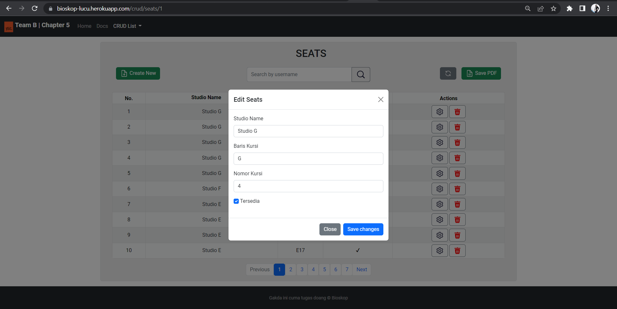

## **Create New Seat**

**Endpoint Description**

Service berikut ini digunakan untuk menambahkan data kursi bioskop yang baru kedalam database.

**Request URL**

|  |
| --- |
| https://bioskop-lucu.herokuapp.com/crud/seats/1 |

**General Information**

|  |  |
| --- | --- |
| HTTP Method | GET |
| Path | /seat |
| Tipe Format | JSON |
| Authentication | - |

**Header Structure**

|  |  |
| --- | --- |
| **Key** | **Value** |
| Content Type | Application/JSON |
| Transfer-Encoding | Chunked |
| Date | Fri, 24 Jun 2022 12:47:04 GMT |
| Keep Alive | timeout=60 |
| Connection | keep alive |

**Request Structure**

**JSON**

|  |
| --- |
| **Request Structure** |
| {  "seatId": 10,  "studioName": "c",  "nomorKursi": 37,  "isAvailable": true,  "createdAt": "2022-06-26T14:29:56.662Z",  "updatedAt": "2022-06-26T14:29:56.662Z"  } |

|  |  |  |  |  |  |
| --- | --- | --- | --- | --- | --- |
| **Field** | **Data Type** | **Mandatory** | **Length** | **Description** | **Example** |
| seatId | Integer | - | - | Primary key dari seat | 3 |
| studioName | String | - | 50 | nama dari studio bioskop | Studio A |
| isAvailable | Boolean | - | 1 | status kursi yg tersedia | true |
| createdAt | String | - | 1 | waktu pertama kali data kursi diinput | 2022-06-13 23:58:01 |
| createdAt | String | - | 1 | waktu pertama kali data kursi diupdate | 2022-01-07 05:08:16 |

**Response Structure**

**JSON**

|  |
| --- |
| **Response Structure** |
| {  {  "data": {  "seatId": 66,  "studioName": "A",  "barisKursi": null,  "isAvailable": true,  "nomorKursi": 38,  "createdAt": "2022-06-26T14:29:56.662",  "updatedAt": "2022-06-26T14:29:56.662"  },  "message": "Seat Successfully Recorded",  "status": "OK"  }  } |

|  |  |  |  |  |  |
| --- | --- | --- | --- | --- | --- |
| **Field** | **Data Type** | **Mandatory** | **Length** | **Description** | **Example** |
| seatId | Integer | - | - | Primary key dari seat | 3 |
| studioName | String | - | 50 | nama dari studio bioskop | Studio A |
| nomorKursi | Integer | - | - | nomor dari kursi bioskop | 5 |
| isAvailable | Boolean | - | 1 | status kursi yg tersedia | true |
| createdAt | String | - | 1 | waktu pertama kali data kursi diinput | 2022-06-13 23:58:01 |
| createdAt | String | - | 1 | waktu pertama kali data kursi diupdate | 2022-01-07 05:08:16 |

**Create Seat with Tyhmleaf - Bootstrap :**

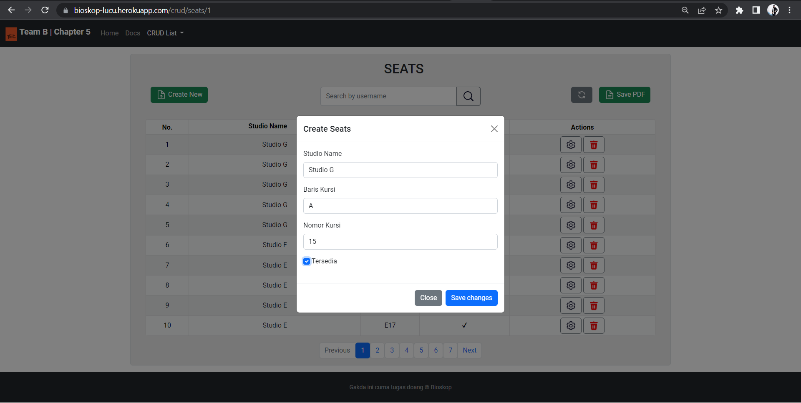

## **Delete Seat By Id**

**Endpoint Description**

Service berikut ini digunakan untuk menghapus data seat di dalam database.

**Request URL**

|  |
| --- |
| https://bioskop-lucu.herokuapp.com/crud/seats/1 |

**General Information**

|  |  |
| --- | --- |
| HTTP Method | GET |
| Path | /seats/{id} |
| Tipe Format | JSON |
| Authentication | - |

**Header Structure**

|  |  |
| --- | --- |
| Key | Value |
| Content Type | Application/JSON |
| Transfer-Encoding | Chunked |
| Date | Fri, 24 Jun 2022 12:47:04 GMT |
| Keep Alive | timeout=60 |
| Connection | keep alive |

**Request Structure**

* Path Variable for delete one data

**Response Structure**

* HTTP STATUS OK (200)

|  |
| --- |
| **Request Structure** |
| {  "data": {  "seatId": 66,  "studioName": null,  "barisKursi": null,  "isAvailable": null,  "nomorKursi": null,  "createdAt": null,  "updatedAt": null  },  "message": "Seat Deleted!",  "status": "OK"  } |

|  |  |  |  |  |  |
| --- | --- | --- | --- | --- | --- |
| **Field** | **Data Type** | **Mandatory** | **Length** | **Description** | **Example** |
| seatId | Integer | - | - | Primary key dari seat | 2 |
| studioName | String | - | 50 | nama dari studio bioskop | Studio A |
| nomorKursi | Integer | - | - | nomor dari kursi bioskop | 5 |
| isAvailable | Boolean | - | 1 | status kursi yg tersedia | true |
| createdAt | String | - | 1 | waktu pertama kali data kursi diinput | 2022-06-13 23:58:01 |
| updatedAt | String | - | 1 | waktu pertama kali data kursi diupdate | 2022-01-07 05:08:16 |
| message | string | - | - | menampilkan pesan succesful/failed | seat deleted |
| status | string | - | - | pesan dari HTTPS Status | OK |

**Delete Seat with Tyhmleaf - Bootstrap :**

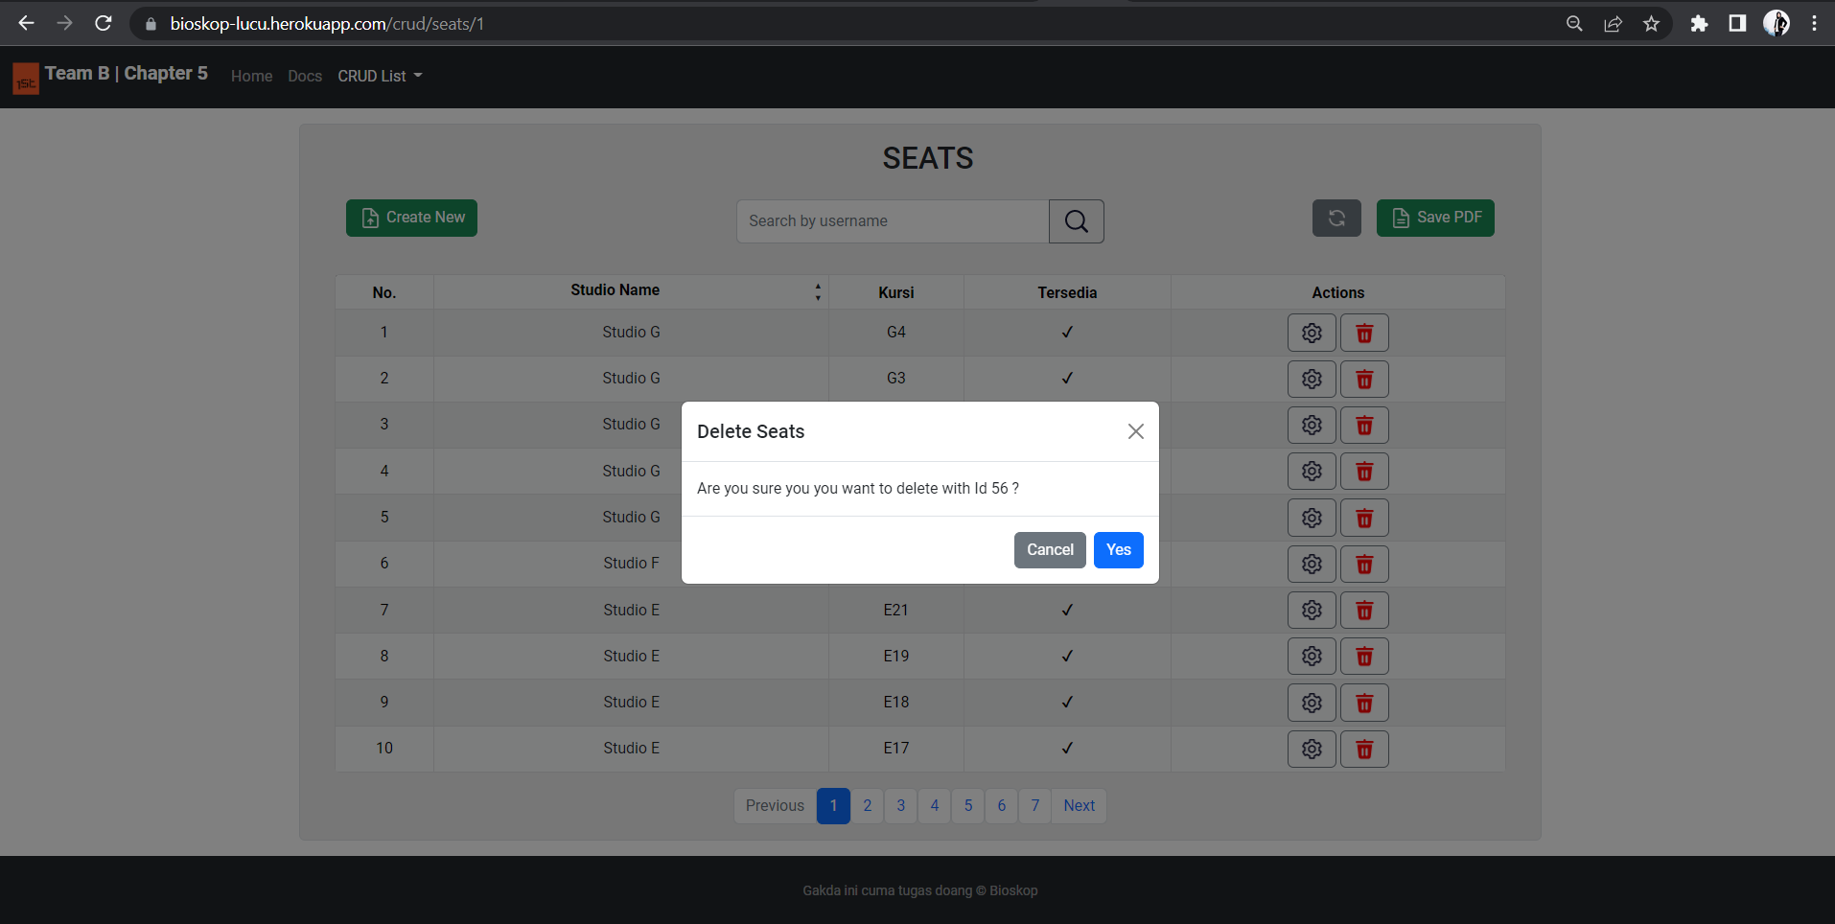

# **SPESIFIKASI ENDPOINT SCHEDULE**

## **Get All Schedule**

**Endpoint Description**

Service berikut ini digunakan untuk mengambil keseluruhan jadwal film yang ada di database.

**Request URL**

|  |
| --- |
| https://bioskop-lucu.herokuapp.com/crud/schedule/1 |

**General Information**

|  |  |
| --- | --- |
| HTTP Method | GET |
| Path | /schedules |
| Tipe Format | JSON |
| Authentication | - |

**Header Structure**

|  |  |
| --- | --- |
| Key | Value |
| APP NAME | BIOSKOP API KELOMPOK 1 |
| Content Type | Application/JSON |
| Transfer-Encoding | Chunked |
| Date | Fri, 24 Jun 2022 12:47:04 GMT |
| Keep Alive | timeout=60 |
| Connection | keep alive |

**Request Structure**

* Structure is Not Available if fetching all data
* Path Variable if fetching one data

**Response Structure**

**JSON**

|  |
| --- |
| **Response Structure** |
| {  "data": [  {  "scheduleId": 44,  "films": {  "filmCode": 60695,  "seatId": {  "seatId": 30,  "studioName": "Studio D",  "barisKursi": "D",  "isAvailable": true,  "nomorKursi": 1,  "createdAt": "2022-04-15T17:02:24",  "updatedAt": "2022-01-31T22:53:04"  },  "filmName": "The Matrix : Revolution",  "isPlaying": false,  "createdAt": "2022-07-28T02:24:19",  "updatedAt": "2022-02-22T05:28:34"  },  "tanggalTayang": "2022-06-08",  "jamMulai": "15:00:00",  "jamSelesai": "17:50:00",  "hargaTiket": 50000,  "createdAt": "2022-05-07T16:09:30",  "updatedAt": "2022-09-27T18:38:50"  }  ],  "accessed_time": "2022-06-29T12:44:14.4399044+09:00"  },  "statusCode": "OK",  "statusCodeValue": 200  } |

**Response headers**

|  |  |  |  |  |  |
| --- | --- | --- | --- | --- | --- |
| **Field** | **Data Type** | **Mandatory** | **Length** | **Description** | **Example** |
| scheduleId | Integer | - | - | Nomor jadwal | 1 |
| filmsCode | Integer | - | 5 | Kode film yang merepresentasikan film itu sendiri | 44532 |
| seatId | Integer | - | - | Primary Key dari kursi | 3 |
| studioName | String | - | 50 | Nama Studio | Studio B |
| nomorKursi | Integer | - | - | Nomor Kursi | 1 |
| barisKursi | Character | - | 1 | Baris Kursi | A |
| isAvailable | Boolean | - | - | Status kursi tersedia | true |
| createdAt | DateTime | - | - | Waktu pertama kali data kursi diinputkan | 2022-06-24T09:34:27 |
| updatedAt | DateTime | - | - | Waktu terakhir data kursi diupdate | 2022-06-24T09:34:27 |
| filmName | String | - | 100 | Judul Film | Avengers: Civil War |
| isPlaying | Boolean | - | 1 | Status film tayang | true |
| createdAt | DateTime | - | - | Waktu pertama kali data film diinputkan | 2022-06-24T09:34:27 |
| updatedAt | DateTime | - | - | Waktu terakhir data film diupdate | 2022-06-24T09:34:27 |
| tanggalTayang | Date | - | - | Tanggal film ditayangkan | 2021-12-29 |
| jamMulai | Time | - | - | Jam film dimulai | 12:00:00 |
| jamSelesai | Time | - | - | Jam film selesai | 13:00:00 |
| hargaTiket | Double | - | - | Harga Tiket | 29000 |
| createdAt | DateTime | - | - | Waktu pertama kali data jadwal diinputkan | 2022-06-24T09:34:27 |
| updatedAt | DateTime | - | - | Waktu terakhir kali data jadwal diupdate | 2022-06-24T09:34:27 |

**Get All Schedule with Tyhmleaf - Bootstrap :**

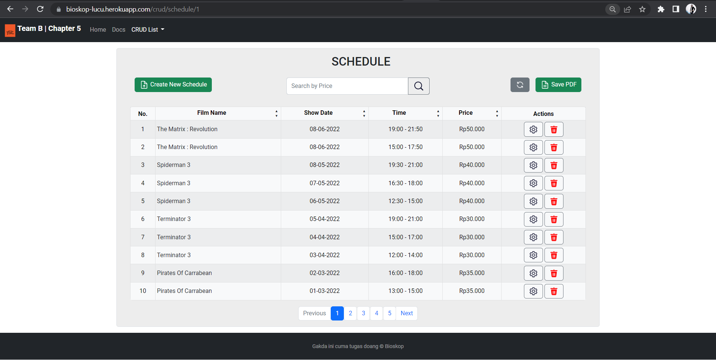

## **Get Schedule by Price**

**Endpoint Description**

Service berikut ini digunakan untuk mengambil salah satu jadwal film yang ada di database.

**Request URL**

|  |
| --- |
| https://bioskop-lucu.herokuapp.com/crud/schedule/1 |

**General Information**

|  |  |
| --- | --- |
| HTTP Method | GET |
| Path | /schedule/{id} |
| Tipe Format | JSON |
| Authentication | - |

**Header Structure**

|  |  |
| --- | --- |
| Key | Value |
| APP NAME | BIOSKOP API KELOMPOK 1 |
| Content Type | Application/JSON |
| Transfer-Encoding | Chunked |
| Date | Fri, 24 Jun 2022 12:47:04 GMT |
| Keep Alive | timeout=60 |
| Connection | keep alive |

**Request Structure**

* Path Variable

**Response Structure**

**JSON**

|  |
| --- |
| **Response Structure** |
| {  "headers": {  "APP-NAME": [  "BIOSKOP API KELOMPOK 1"  ]  },  "body": {  "error_message": "",  "data": {  "filmsCode": 34285,  "tanggalTayang": "2021-12-29",  "jamMulai": "12:00:00",  "jamSelesai": "14:55:00",  "hargaTiket": 29472,  "createdAt": "2022-07-17T12:00:16"  },  "accessed_time": "2022-06-29T01:27:35.6051024+09:00"  },  "statusCode": "OK",  "statusCodeValue": 200 |

|  |  |  |  |  |  |
| --- | --- | --- | --- | --- | --- |
| **Field** | **Data Type** | **Mandatory** | **Length** | **Description** | **Example** |
| scheduleId | Integer | - | - | Nomor jadwal | 53 |
| filmsCode | Integer | - | 5 | Kode film yang merepresentasikan film itu sendiri | 34285 |
| seatId | Integer | - | - | Primary Key dari kursi | 1 |
| studioName | String | - | 50 | Nama Studio | Studio A |
| nomorKursi | Integer | - | - | Nomor Kursi | 1 |
| barisKursi | Character | - | 1 | Baris Kursi | A |
| isAvailable | Boolean | - | - | Status kursi tersedia | true |
| createdAt | DateTime | - | - | Waktu pertama kali data kursi diinputkan | 2022-06-24T09:34:27 |
| updatedAt | DateTime | - | - | Waktu terakhir data kursi diupdate (jika tidak ada update terakhir akan terisi null) | null |
| filmName | String | - | 100 | Judul Film | Blood and Sand |
| isPlaying | Boolean | - | 1 | Status film tayang | true |
| createdAt | DateTime | - | - | Waktu pertama kali data film diinputkan | 2022-06-24T09:34:27 |
| updatedAt | DateTime | - | - | Waktu terakhir data film diupdate (jika tidak ada update terakhir akan terisi null) | null |
| tanggalTayang | Date | - | - | Tanggal film ditayangkan | 2022-06-25 |
| jamMulai | Time | - | - | Jam film dimulai | 16:00:00 |
| jamSelesai | Time | - | - | Jam film selesai | 17:00:00 |
| hargaTiket | Double | - | - | Harga Tiket | 700 |
| createdAt | DateTime | - | - | Waktu pertama kali data jadwal diinputkan | 2022-06-24T09:34:27 |
| updatedAt | DateTime | - | - | Waktu terakhir kali data jadwal diupdate | 2022-06-25T12:58:05 |

**Get Schedule by Price with Tyhmleaf - Bootstrap :**

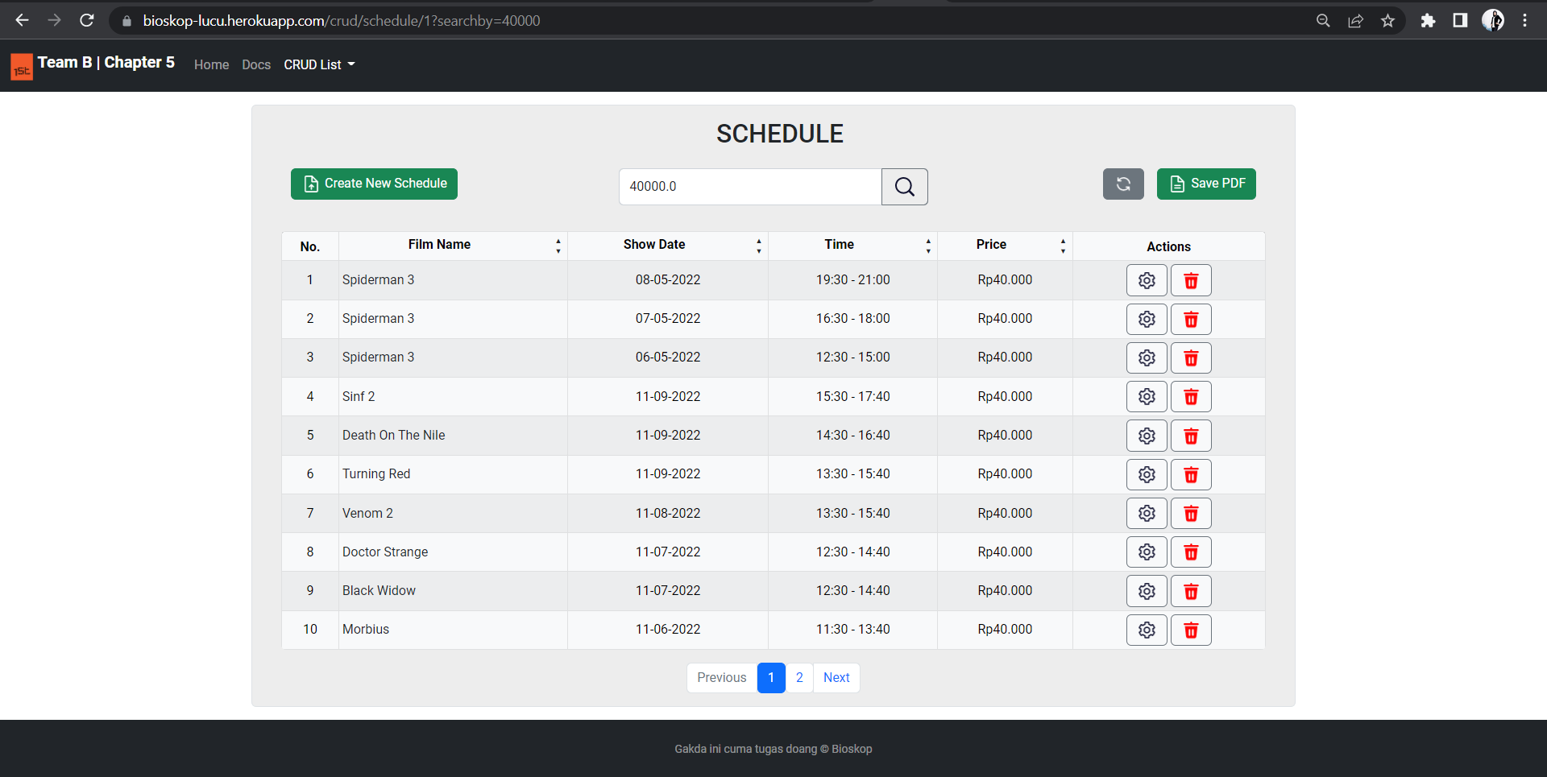

## **Update Schedule by Id**

**Endpoint Description**

Service berikut ini digunakan untuk memperbaharui jadwal film yang telah dibuat sebelumnya berdasarkan Id Path Variable pada Endpoint.

**Request URL**

|  |
| --- |
| https://bioskop-lucu.herokuapp.com/crud/schedule/1 |

**General Information**

|  |  |
| --- | --- |
| HTTP Method | GET |
| Path | /schedule/{id} |
| Tipe Format | JSON |
| Authentication | - |

**Header Structure**

|  |  |
| --- | --- |
| Key | Value |
| APP NAME | BIOSKOP API KELOMPOK 1 |
| Content Type | Application/JSON |
| Transfer-Encoding | Chunked |
| Date | Fri, 24 Jun 2022 12:47:04 GMT |
| Keep Alive | timeout=60 |
| Connection | keep alive |

**Request Structure**

* **Path Variable**
* **JSON**

|  |
| --- |
| **Request Structure** |
| {  "films": {  "filmCode": 34285  },  "tanggalTayang": "2021-12-29",  "jamMulai": "12:00:00",  "jamSelesai": "13:00:00",  "hargaTiket": 29000  } |

|  |  |  |  |  |  |
| --- | --- | --- | --- | --- | --- |
| **Field** | **Data Type** | **Mandatory** | **Length** | **Description** | **Example** |
| filmsCode | Integer | - | 5 | Kode film yang merepresentasikan film | 34285 |
| tanggalTayang | Date | - | - | Tanggal film ditayangkan | 2021-12-29 |
| jamMulai | Time | - | - | Jam film dimulai | 12:00:00 |
| jamSelesai | Time | - | - | Jam film selesai | 13:00:00 |
| hargaTiket | Double | - | - | Harga Tiket | 29000 |

**Response Structure**

**JSON**

|  |
| --- |
| **Response Strukture** |
| {  "headers": {  "APP-NAME": [  "BIOSKOP API KELOMPOK 1"  ]  },  "body": {  "error_message": "",  "data": {  "filmsCode": 102114,  "tanggalTayang": "2021-12-30",  "jamMulai": "12:00:00",  "jamSelesai": "13:00:00",  "hargaTiket": 30000,  "createdAt": null  },  "accessed_time": "2022-06-29T13:29:37.940874+09:00"  },  "statusCode": "OK",  "statusCodeValue": 200  } |

|  |  |  |  |  |  |
| --- | --- | --- | --- | --- | --- |
| **Field** | **Data Type** | **Mandatory** | **Length** | **Description** | **Example** |
| scheduleId | Integer | - | - | Nomor jadwal | 59 |
| filmsCode | Integer | - | 5 | Kode film yang merepresentasikan film itu sendiri | 34285 |
| seatId | Integer | - | - | Primary Key dari kursi | 1 |
| studioName | String | - | 50 | Nama Studio | Studio A |
| nomorKursi | Integer | - | - | Nomor Kursi | 1 |
| barisKursi | Character | - | 1 | Baris Kursi | A |
| isAvailable | Boolean | - | - | Status kursi tersedia | true |
| createdAt | DateTime | - | - | Waktu pertama kali data kursi diinputkan | 2022-06-24T09:34:27 |
| updatedAt | DateTime | - | - | Waktu terakhir data kursi diupdate (jika tidak ada update terakhir akan terisi null) | null |
| filmName | String | - | 100 | Judul Film | Blood and Sand |
| isPlaying | Boolean | - | 1 | Status film tayang | true |
| createdAt | DateTime | - | - | Waktu pertama kali data film diinputkan | 2022-06-24T09:34:27 |
| updatedAt | DateTime | - | - | Waktu terakhir data film diupdate (jika tidak ada update terakhir akan terisi null) | null |
| tanggalTayang | Date | - | - | Tanggal film ditayangkan | 2022-06-25 |
| jamMulai | Time | - | - | Jam film dimulai | 16:00:00 |
| jamSelesai | Time | - | - | Jam film selesai | 17:00:00 |
| hargaTiket | Double | - | - | Harga Tiket | 700 |
| createdAt | DateTime | - | - | Waktu pertama kali data jadwal diinputkan (jika tidak ada perubahan data akan terisi null) | null |
| updatedAt | DateTime | - | - | Waktu terakhir kali data jadwal diupdate | 2022-06-25T13:22:57 |

**Update Schedule with Tyhmleaf - Bootstrap :**

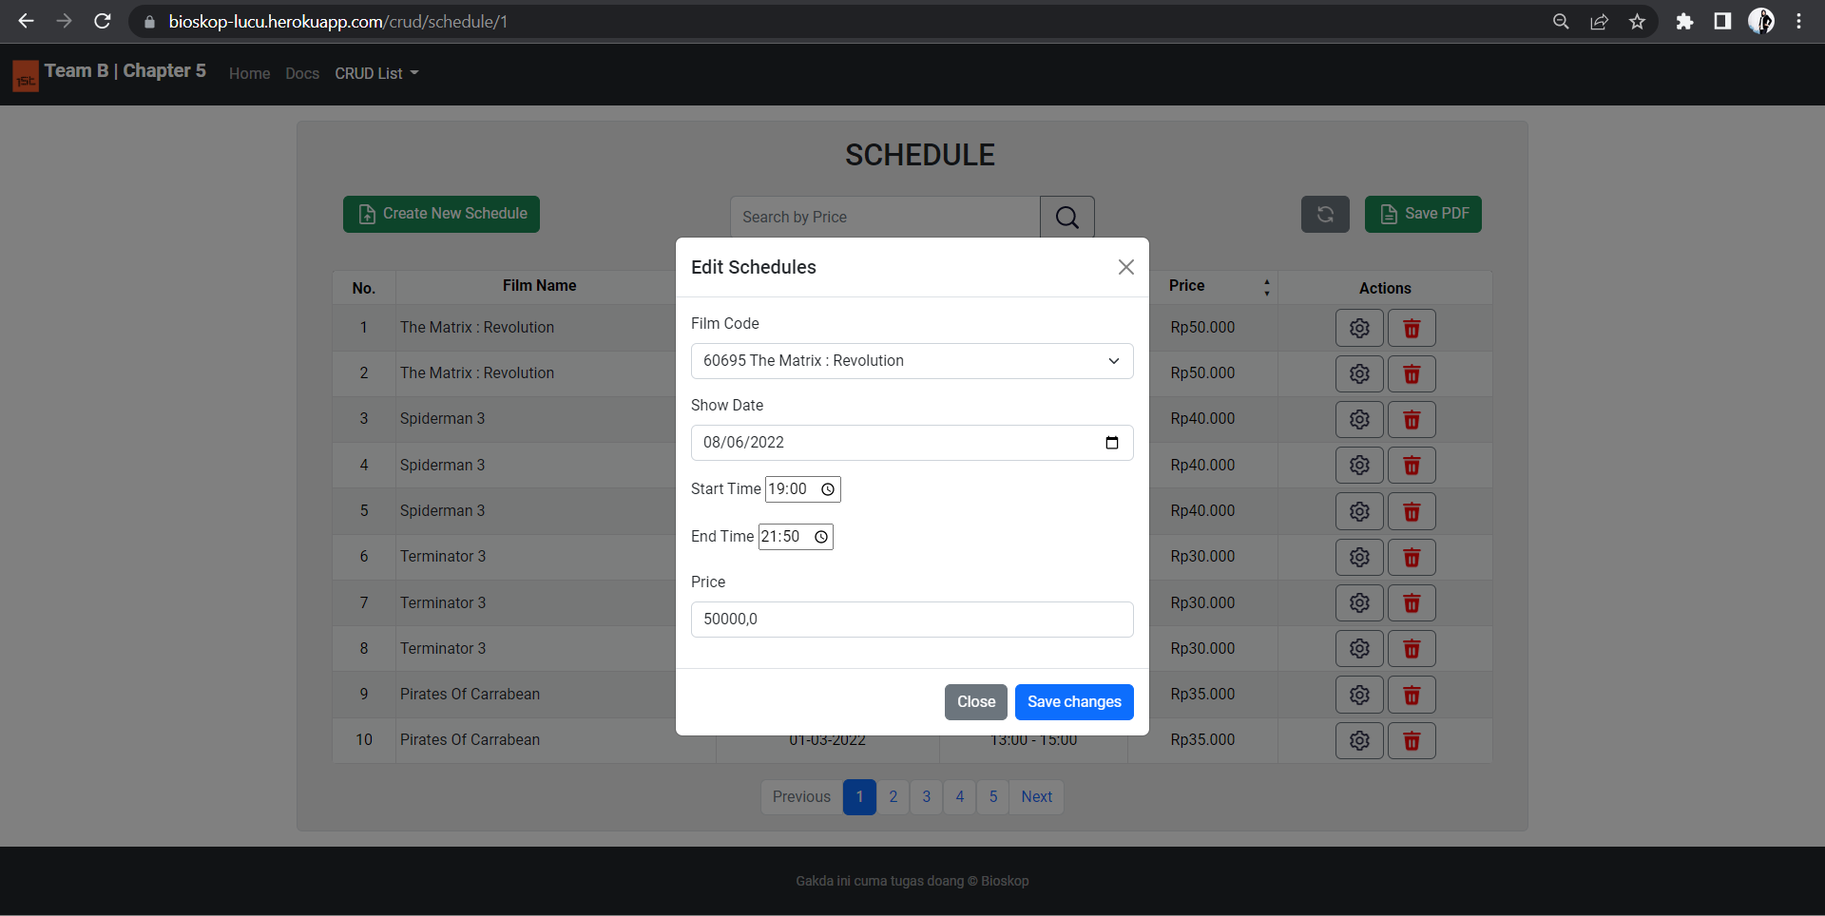

## **Create New Schedule**

**Endpoint Description**

Service berikut ini digunakan untuk membuat jadwal film yang baru.

**Request URL**

|  |
| --- |
| https://bioskop-lucu.herokuapp.com/crud/schedule/1 |

**General Information**

|  |  |
| --- | --- |
| HTTP Method | POST |
| Path | /schedule |
| Tipe Format | JSON |
| Authentication | - |

**Header Structure**

|  |  |
| --- | --- |
| Key | Value |
| APP NAME | BIOSKOP API KELOMPOK 1 |
| Content Type | Application/JSON |
| Transfer-Encoding | Chunked |
| Date | Fri, 24 Jun 2022 12:47:04 GMT |
| Keep Alive | timeout=60 |
| Connection | keep alive |

**Request Structure**

**JSON**

|  |
| --- |
| **Request Structure** |
| {  "films": {  "filmCode": 34285  },  "tanggalTayang": "2021-12-29",  "jamMulai": "12:00:00",  "jamSelesai": "13:00:00",  "hargaTiket": 29000  } |

|  |  |  |  |  |  |
| --- | --- | --- | --- | --- | --- |
| **Field** | **Data Type** | **Mandatory** | **Length** | **Description** | **Example** |
| filmsCode | Integer | - | 5 | Kode film yang merepresentasikan film | 34285 |
| tanggalTayang | Date | - | - | Tanggal film ditayangkan | 2021-12-29 |
| jamMulai | Time | - | - | Jam film dimulai | 12:00:00 |
| jamSelesai | Time | - | - | Jam film selesai | 13:00:00 |
| hargaTiket | Double | - | - | Harga Tiket | 29000 |

**Response Structure**

**JSON**

|  |
| --- |
| **Response Structure** |
| },  "body": {  "error_message": "",  "data": {  "filmsCode": 34285,  "tanggalTayang": "2021-12-30",  "jamMulai": "12:00:00",  "jamSelesai": "13:00:00",  "hargaTiket": 30000,  "createdAt": "2022-06-29T10:52:14.6709592"  },  "accessed_time": "2022-06-29T12:52:14.6919438+09:00"  },  "statusCode": "CREATED",  "statusCodeValue": 201  } |

|  |  |  |  |  |  |
| --- | --- | --- | --- | --- | --- |
| **Field** | **Data Type** | **Mandatory** | **Length** | **Description** | **Example** |
| scheduleId | Integer | - | - | Id Jadwal yang telah dibuat | 54 |
| filmsCode | Integer | - | 5 | Kode film yang merepresentasikan film | 34285 |
| tanggalTayang | Date | - | - | Tanggal film ditayangkan | 2021-12-29 |
| jamMulai | Time | - | - | Jam film dimulai | 16:00:00 |
| jamSelesai | Time | - | - | Jam film selesai | 17:00:00 |
| hargaTiket | Double | - | - | Harga Tiket | 29000 |
| createdAt | DateTime | - | - | Waktu pertama kali data jadwal diinputkan | 2022-06-24T09:34:27 |
| updatedAt | DateTime | - | - | Waktu terakhir kali data jadwal diupdate | 2022-06-24T09:34:27 |

**Create Schedule with Tyhmleaf - Bootstrap :**

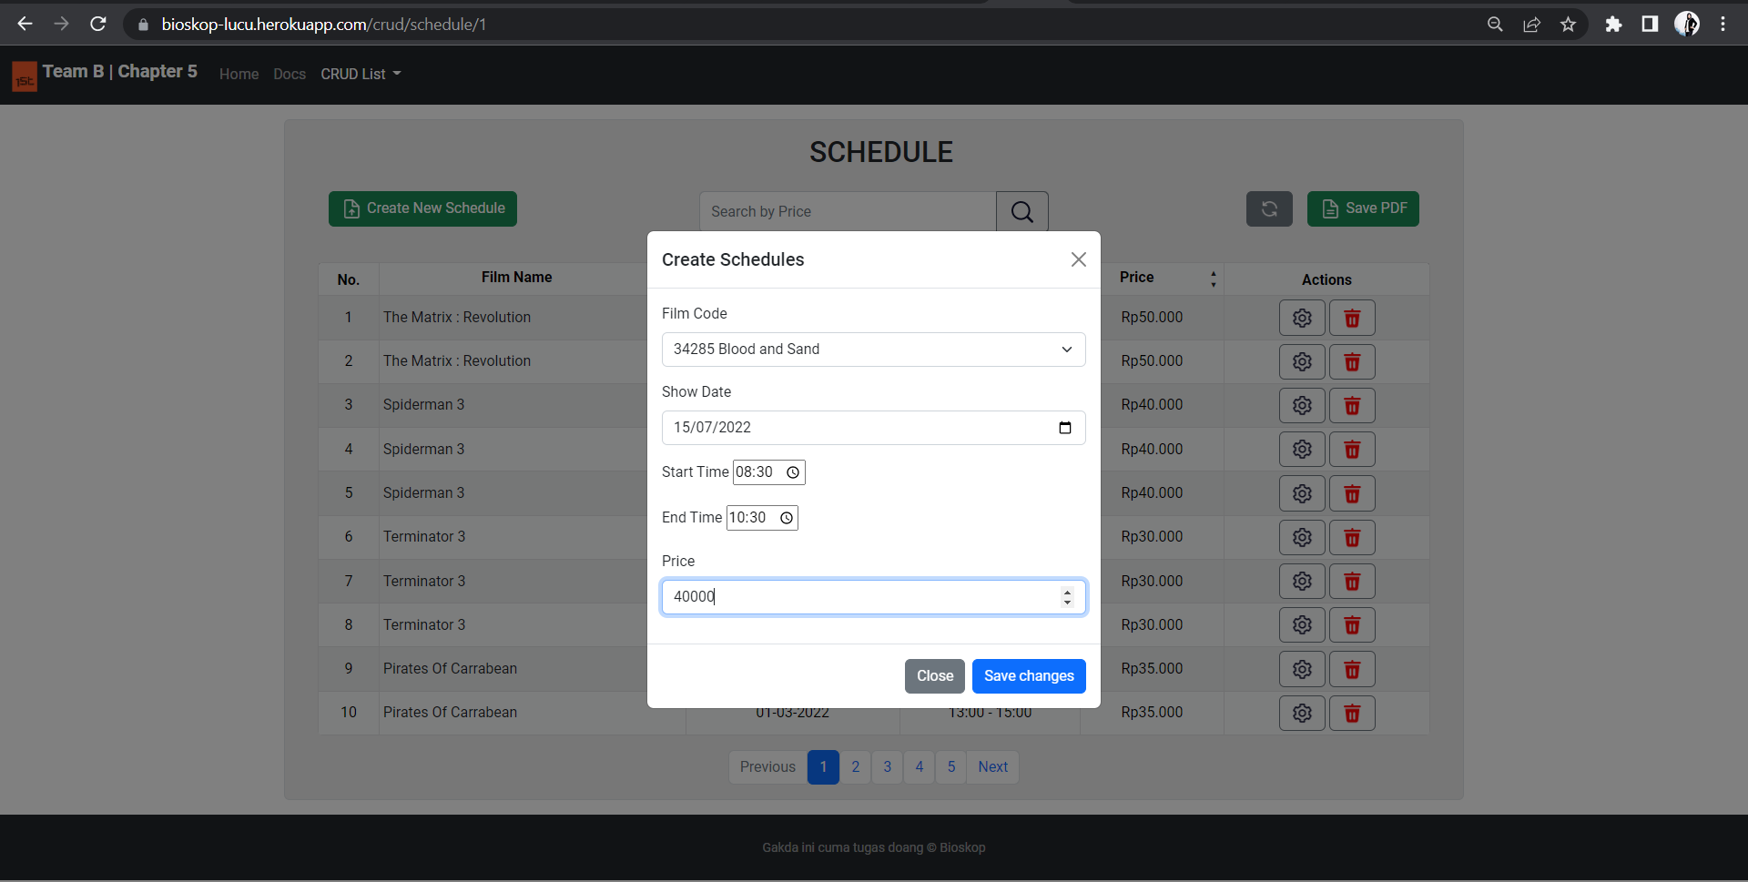

## **Delete Schedule by Id**

**Endpoint Description**

Service berikut ini digunakan untuk menghapus secara *hard-delet* jadwal film yang telah dibuat sebelumnya berdasarkan Id Path Variable pada Endpoint.

**Request URL**

|  |
| --- |
| https://bioskop-lucu.herokuapp.com/crud/schedule/1 |

**General Information**

|  |  |
| --- | --- |
| HTTP Method | GET |
| Path | /schedule/{id} |
| Tipe Format | JSON |
| Authentication | - |

**Header Structure**

|  |  |
| --- | --- |
| Key | Value |
| APP NAME | BIOSKOP API KELOMPOK 1 |
| Content Type | Application/JSON |
| Transfer-Encoding | Chunked |
| Date | Fri, 24 Jun 2022 12:47:04 GMT |
| Keep Alive | timeout=60 |
| Connection | keep alive |

**Request Structure**

* Path Variable for delete one data

**Response Structure**

* HTTP STATUS OK (200)

|  |
| --- |
| **Response Structure** |
| {  "body": {  "error_message": "",  "data": "Data is deleted",  "accessed_time": "2022-06-29T12:49:02.7588749+09:00"  },  }  {  "headers": {  "APP-NAME": [  "BIOSKOP API KELOMPOK 1"  ]  },  "body": {  "error_message": "",  "data": "Data is deleted",  "accessed_time": "2022-06-29T12:49:02.7588749+09:00"  },  "statusCode": "OK",  "statusCodeValue": 200  } |

**Delete Schedule with Tyhmleaf - Bootstrap :**

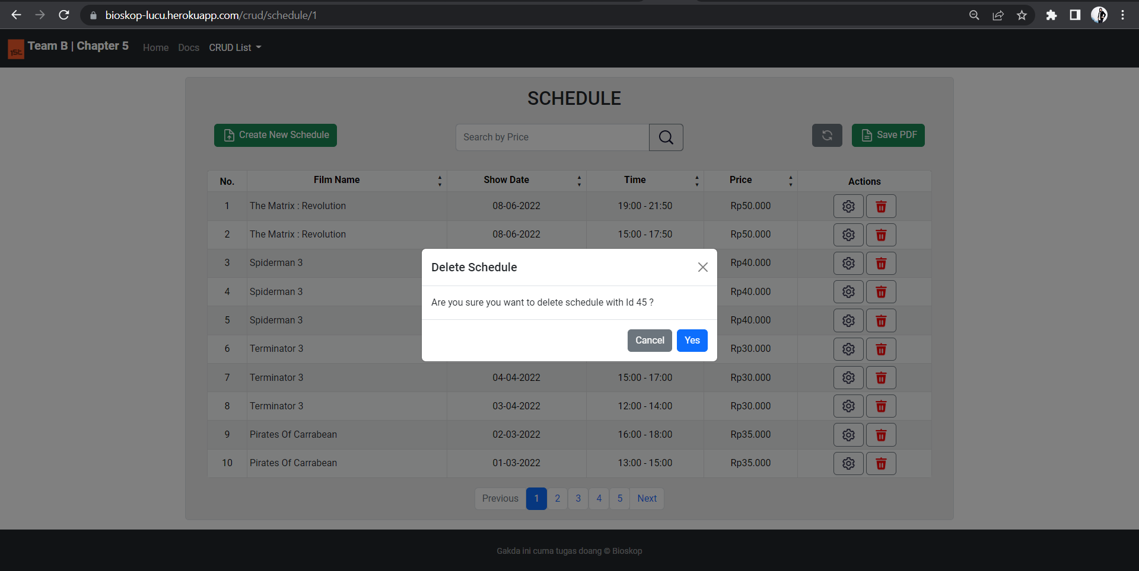

# **SPESIFIKASI ENDPOINT RESERVATIONS**

## **Get All Reservations**

**Endpoint Description**

Service berikut ini digunakan untuk mengambil keseluruhan data reservasi tiket film bioskop yang ada di database.

**Request URL**

|  |
| --- |
| https://bioskop-lucu.herokuapp.com/crud/reservations/1 |

**General Information**

|  |  |
| --- | --- |
| HTTP Method | GET |
| Path | /reservations |
| Tipe Format | JSON |
| Authentication | - |

**Header Structure**

|  |  |
| --- | --- |
| Key | Value |
| APP NAME | BIOSKOP API FINAL PROJECT TIM B |
| Content Type | Application/JSON |
| Transfer-Encoding | Chunked |
| Date | Sun,03 Jul 2022 17:17:06 GMT |
| Keep Alive | timeout=60 |
| Connection | keep alive |

**Request Structure**

* Structure is Not Available if fetching all data
* Path Variable if fetching one data

**Response Structure**

**JSON**

|  |
| --- |
| **Response Structure** |
| {  "data": [  {  "reservationId": 1,  "userId": 1,  "scheduleId": 1,  "isActive": true,  "createdAt": "2022-07-03T22:24:08",  "updatedAt": "2022-07-03T23:24:08"  },  {  "reservationId": 2,  "userId": 2,  "scheduleId": 2,  "isActive": true,  "createdAt": "2022-07-03T22:44:08",  "updatedAt": "2022-07-03T23:54:08"  }  ],  "message": "Successfully retrieved data!",  "status": "OK"  } |

**Response headers**

|  |  |  |  |  |  |
| --- | --- | --- | --- | --- | --- |
| **Field** | **Data Type** | **Mandatory** | **Length** | **Description** | **Example** |
| reservationId | Integer | - | 10 | Nomor jadwal reservasi | 1 |
| userId | Integer | - | 10 | Kode user id yang merepresentasikan user | 1 |
| scheduleId | Integer | - | 10 | Nomor jadwal | 1 |
| isActive | Boolean | - | 1 | Status film tayang | true |
| createdAt | DateTime | - | - | Waktu pertama kali data reservation diinputkan | 2022-07-03T22:24:08 |
| updatedAt | DateTime | - | - | Waktu terakhir data reservation diupdate | 2022-07-03T22:24:08 |

**Get All Reservations with Tyhmleaf - Bootstrap :**

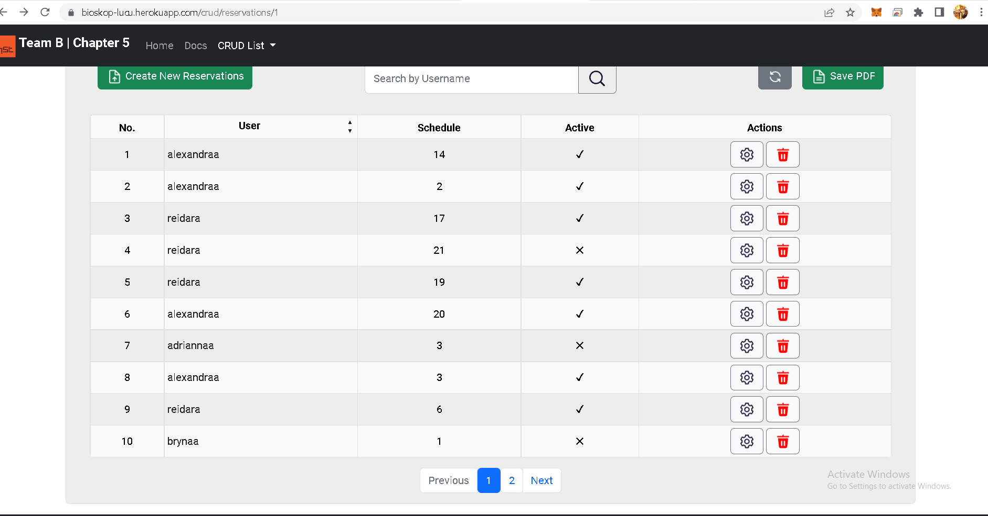

## **Get Reservations by Username**

**Endpoint Description**

Service berikut ini digunakan untuk mengambil data reservasi tiket film di bioskop berdasarkan ID reservasi.

**Request URL**

|  |
| --- |
| https://bioskop-lucu.herokuapp.com/crud/reservations/1 |

**General Information**

|  |  |
| --- | --- |
| HTTP Method | GET |
| Path | /reservations/{id} |
| Tipe Format | JSON |
| Authentication | - |

**Header Structure**

|  |  |
| --- | --- |
| Key | Value |
| APP NAME | BIOSKOP API FINAL PROJECT TIM B |
| Content Type | Application/JSON |
| Transfer-Encoding | Chunked |
| Date | Sun,03 Jul 2022 17:47:46 GMT |
| Keep Alive | timeout=60 |
| Connection | keep alive |

**Request Structure**

* Path Variable

**Response Structure**

**JSON**

|  |
| --- |
| **Response Structure** |
| {  "data": {  "reservationId": 1,  "userId": 1,  "scheduleId": 1,  "isActive": true,  "createdAt": "2022-07-03T22:24:08",  "updatedAt": "2022-07-03T23:24:08"  },  "message": "Successfully retrieved data!",  "status": "OK"  } |

**Response headers**

|  |  |  |  |  |  |
| --- | --- | --- | --- | --- | --- |
| **Field** | **Data Type** | **Mandatory** | **Length** | **Description** | **Example** |
| reservationId | Integer | - | 10 | Nomor jadwal reservasi | 1 |
| userId | Integer | - | 10 | Kode user id yang merepresentasikan user | 1 |
| scheduleId | Integer | - | 10 | Nomor jadwal | 1 |
| isActive | Boolean | - | 1 | Status film tayang | true |
| createdAt | DateTime | - | - | Waktu pertama kali data reservation diinputkan | 2022-07-03T22:24:08 |
| updatedAt | DateTime | - | - | Waktu terakhir data reservation diupdate | 2022-07-03T22:24:08 |

**Get Reservations by Username with Tyhmleaf - Bootstrap :**

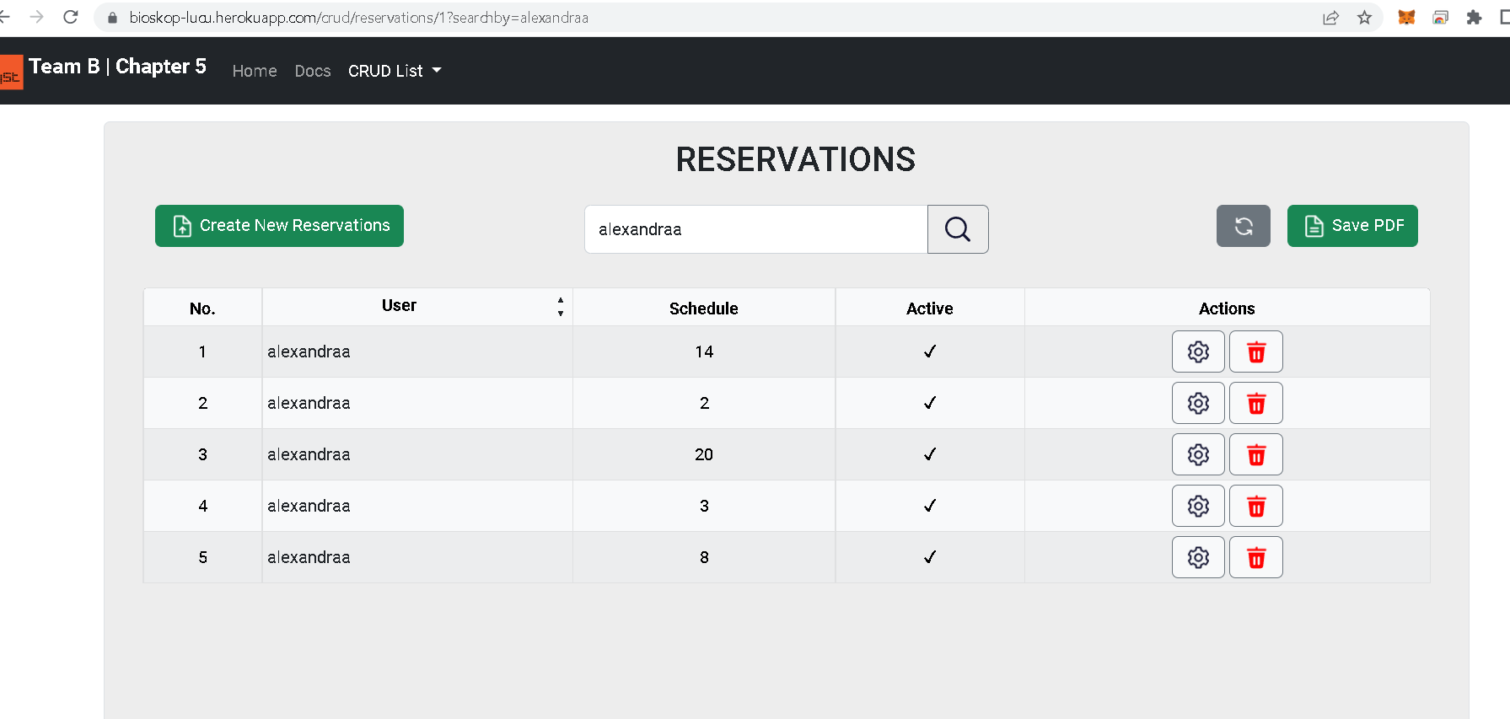

## **Update Reservations by ID**

**Endpoint Description**

Service berikut ini digunakan untuk memperbaharui reservasi yang telah dibuat sebelumnya berdasarkan Id Path Variable pada Endpoint.

**Request URL**

|  |
| --- |
| https://bioskop-lucu.herokuapp.com/crud/reservations/1 |

**General Information**

|  |  |
| --- | --- |
| HTTP Method | GET |
| Path | /reservations |
| Tipe Format | JSON |
| Authentication | - |

**Header Structure**

|  |  |
| --- | --- |
| Key | Value |
| APP NAME | BIOSKOP API FINAL PROJECT TIM B |
| Content Type | Application/JSON |
| Transfer-Encoding | Chunked |
| Date | Sun,03 Jul 2022 17:47:46 GMT |
| Keep Alive | timeout=60 |
| Connection | keep alive |

**Request Structure**

* **Path Variable**
* **JSON**

|  |
| --- |
| **Request Structure** |
| {  "reservationId": 11,  "users": {  "userId": 11  },  "schedule": {  "scheduleId": 11  },  "isActive": true  } |

|  |  |  |  |  |  |
| --- | --- | --- | --- | --- | --- |
| **Field** | **Data Type** | **Mandatory** | **Length** | **Description** | **Example** |
| reservationId | Integer | - | 10 | Nomor jadwal reservasi | 2 |
| userId | Integer | - | 10 | Kode user id yang merepresentasikan user | 2 |
| scheduleId | Integer | - | 10 | Nomor jadwal | 2 |
| isActive | Boolean | - | 1 | Status film tayang | true |
| createdAt | DateTime | - | - | Waktu pertama kali data reservation dibuat | 2022-07-06T10:21:34.3739359 |
| updatedAt | DateTime | - | - | Waktu terakhir data reservation diupdate | 2022-07-06T10:41:34.3739359 |

**Response Structure**

**JSON**

|  |
| --- |
| **Response Structure** |
| {  "data": {  "reservationId": 10,  "userId": 11,  "scheduleId": 11,  "isActive": true,  "createdAt": 2022-07-06T10:21:34.3739359,  "updatedAt": "2022-07-06T10:41:34.3739359"  },  "message": "Reservation with id 10 successfully updated",  "status": "OK"  } |

**Response headers**

|  |  |  |  |  |  |
| --- | --- | --- | --- | --- | --- |
| **Field** | **Data Type** | **Mandatory** | **Length** | **Description** | **Example** |
| reservationId | Integer | - | 10 | Nomor jadwal reservasi | 2 |
| userId | Integer | - | 10 | Kode user id yang merepresentasikan user | 2 |
| scheduleId | Integer | - | 10 | Nomor jadwal | 2 |
| isActive | Boolean | - | 1 | Status film tayang | true |
| createdAt | DateTime | - | - | Waktu pertama kali data reservation diinputkan | 2022-07-06T10:21:34.3739359 |
| updatedAt | DateTime | - | - | Waktu terakhir data reservation diupdate | 2022-07-06T10:41:34.3739359 |

**Update Reservations with Tyhmleaf - Bootstrap :**

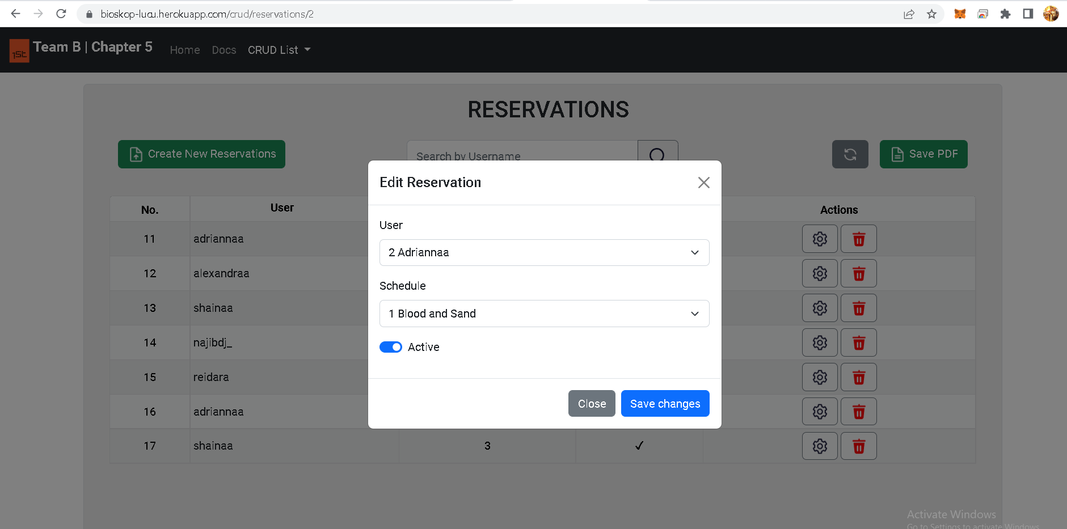

## **Create New Reservations**

**Endpoint Description**

Service berikut ini digunakan untuk membuat reservasi tiket film yang baru.

**Request URL**

|  |
| --- |
| https://bioskop-lucu.herokuapp.com/crud/reservations/1 |

**General Information**

|  |  |
| --- | --- |
| HTTP Method | POST |
| Path | /reservations/{id} |
| Tipe Format | JSON |
| Authentication | - |

**Header Structure**

|  |  |
| --- | --- |
| Key | Value |
| APP NAME | BIOSKOP API FINAL PROJECT TIM B |
| Content Type | Application/JSON |
| Transfer-Encoding | Chunked |
| Date | Sun,03 Jul 2022 17:47:46 GMT |
| Keep Alive | timeout=60 |
| Connection | keep alive |

**Request Structure**

* **Path Variable**
* **JSON**

|  |
| --- |
| Request Structure |
| {  "reservationId": 0,  "users": {  "userId": 6  },  "schedule": {  "scheduleId": 1  },  "isActive": true  } |

|  |  |  |  |  |  |
| --- | --- | --- | --- | --- | --- |
| **Field** | **Data Type** | **Mandatory** | **Length** | **Description** | **Example** |
| reservationId | Integer | - | 10 | Nomor jadwal reservasi | 2 |
| userId | Integer | - | 10 | Kode user id yang merepresentasikan user | 2 |
| scheduleId | Integer | - | 10 | Nomor jadwal | 2 |
| isActive | Boolean | - | 1 | Status film tayang | true |
| createdAt | DateTime | - | - | Waktu pertama kali data reservation diinputkan | 2022-07-03T22:44:08 |

**Response Structure**

**JSON**

|  |
| --- |
| **Response Structure** |
| {  "data": {  "reservationId": 18,  "userId": 6,  "scheduleId": 1,  "isActive": true,  "createdAt": "2022-07-06T10:27:09.6282351",  "updatedAt": "2022-07-06T10:27:09.6282351"  },  "message": "New reservation data successfully created",  "status": "CREATED"  } |

**Response headers**

|  |  |  |  |  |  |
| --- | --- | --- | --- | --- | --- |
| **Field** | **Data Type** | **Mandatory** | **Length** | **Description** | **Example** |
| reservationId | Integer | - | 10 | Nomor jadwal reservasi | 18 |
| userId | Integer | - | 10 | Kode user id yang merepresentasikan user | 6 |
| scheduleId | Integer | - | 10 | Nomor jadwal | 1 |
| isActive | Boolean | - | 1 | Status film tayang | true |
| createdAt | DateTime | - | - | Waktu pertama kali data reservation diinputkan | 2022-07-03T22:24:08 |
| updatedAt | DateTime | - | - | Waktu terakhir data reservation diupdate | 2022-07-03T22:24:08 |

**Create Reservations with Tyhmleaf - Bootstrap :**

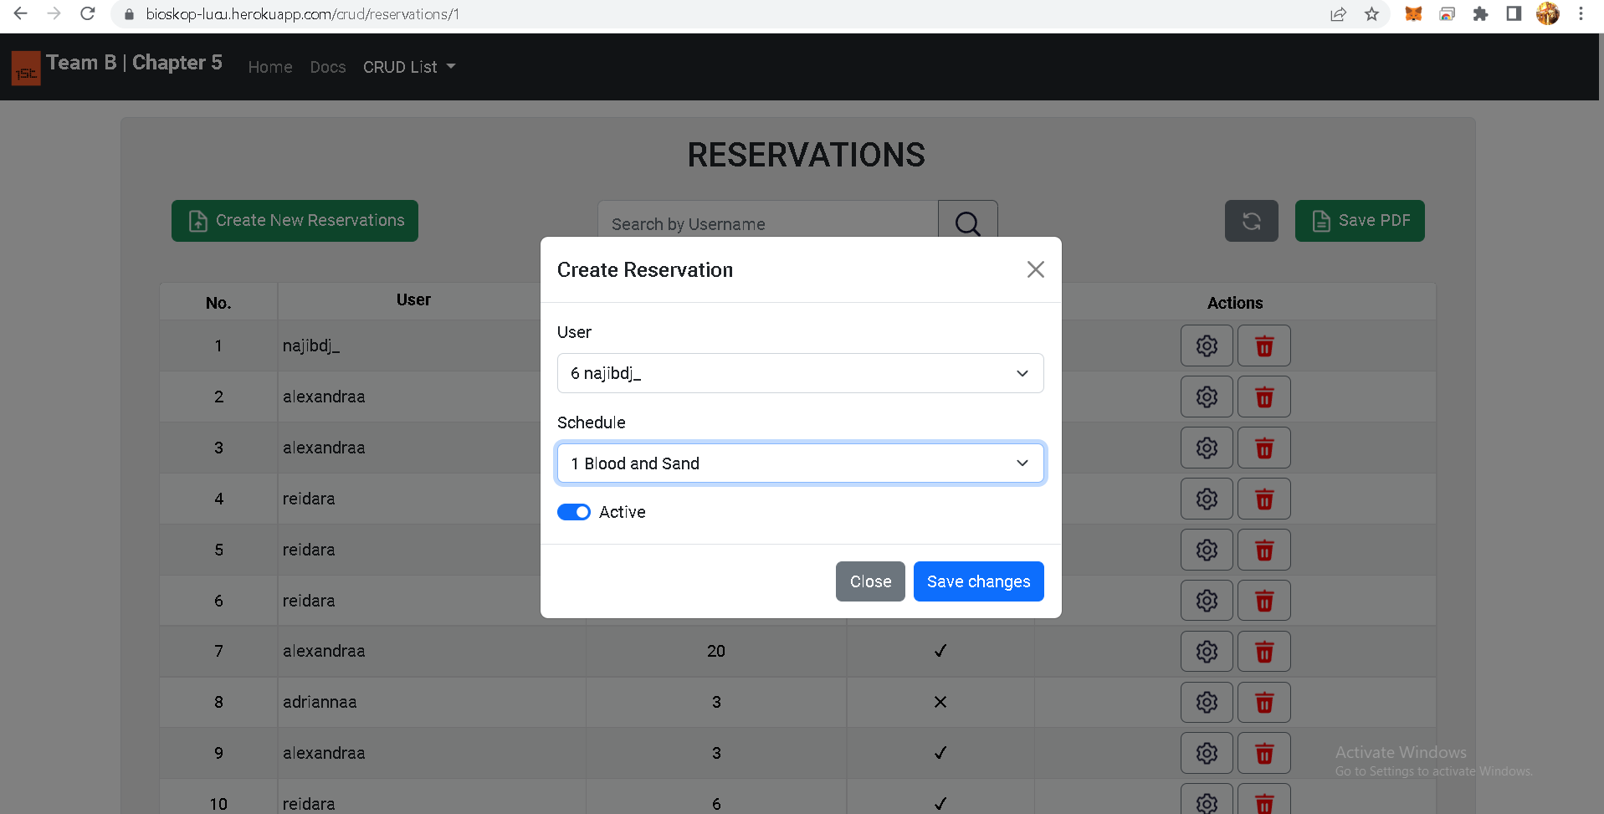

## **Delete Reservations by ID**

**Endpoint Description**

Service berikut ini digunakan untuk menghapus secara *hard-delet* reservasi tiket film yang telah dibuat sebelumnya berdasarkan Id Path Variable pada Endpoint.

**Request URL**

|  |
| --- |
| https://bioskop-lucu.herokuapp.com/crud/reservations/1 |

**General Information**

|  |  |
| --- | --- |
| HTTP Method | DELETE |
| Path | /reservations/{id} |
| Tipe Format | JSON |
| Authentication | - |

**Header Structure**

|  |  |
| --- | --- |
| Key | Value |
| APP NAME | BIOSKOP API FINAL PROJECT TIM B |
| Content Type | Application/JSON |
| Transfer-Encoding | Chunked |
| Date | Sun,03 Jul 2022 18:06:53 GMT |
| Keep Alive | timeout=60 |
| Connection | keep alive |

**Request Structure**

* Path Variable for delete one data

**Response Structure**

**JSON**

|  |
| --- |
| **Response Structure** |
| {  "data": {  "reservationId": 18,  "userId": 6,  "scheduleId": 1,  "isActive": true,  "createdAt": "2022-07-03T22:44:08",  "updatedAt": "2022-07-03T23:54:08"  },  "message": "Successfully delete reservation with id: 2",  "status": "OK"  } |

**Response headers**

|  |  |  |  |  |  |
| --- | --- | --- | --- | --- | --- |
| **Field** | **Data Type** | **Mandatory** | **Length** | **Description** | **Example** |
| reservationId | Integer | - | 10 | Nomor jadwal reservasi | 18 |
| userId | Integer | - | 10 | Kode user id yang merepresentasikan user | 6 |
| scheduleId | Integer | - | 10 | Nomor jadwal | 1 |
| isActive | Boolean | - | 1 | Status film tayang | true |
| createdAt | DateTime | - | - | Waktu pertama kali data reservation diinputkan | 2022-07-03T22:44:08 |
| updatedAt | DateTime | - | - | Waktu terakhir data reservation diupdate | 2022-07-03T23:54:08 |

**Delete Reservations with Tyhmleaf - Bootstrap :**

